REDR Formats for Voyager Radio Occultation Data from Jupiter
an update of
urn:nasa:pds:radiosci.documentation:dsn.redr:1979-11-28
after preparation of the data for PDS archiving

The REDR format was used for radio occultation data distribution from both the Voyager 1 and Voyager 2 encounters with Jupiter. The record structure is described in byte order within each physical record, as shown in Table 1. All structures are described as they appear in the binary files, which were created on a most-significant byte (MSB, or ‘big endian’) platform. The first byte in each record is byte 1; subsequent bytes are numbered 2, 3, 4, etc. Within a byte, the least significant bit is 0 and the most significant bit is bit 7.

Most values in the header (bytes 1-12) and trailer (1613-1692) are unsigned integer; where signed integers are used, a note is included in Table 1. Large values (e.g., 12 or more significant figures) are split into high and low parts, where each can be expressed in 24 bits or fewer. The last four bytes in each record contain ASCII characters. Dates and times are Earth receive time (UTC).

Output from two receivers (one at S-band and the other at X-band) was sampled and recorded coherently. Each sample is an 8-bit two’s complement value stored in the first of two bytes. The second byte was available for 16-bit samples; but it was not used for Voyager and was set to ‘0’. Four analog-to-digital (A/D) converters sampled the receiver outputs; one was assigned to the S-band receiver, and the other three were assigned to the X-band receiver. Each sampled at a rate of 10000 per second; the X-band A/D converters were phased so that the effective rate at X-band was 30000/second. The S- and X-band samples are interleaved throughout each data record (bytes 13-1612), as shown in Table 1.

- Record Year, Day, Hour, Minute, and Second (bytes 1-7) is a time tag associated with the first sample from each receiver (bytes 13 and 15). It must be adjusted for buffering and hardware delays within the data collection system. See paragraph 19 below.

- Data Validity Flag (byte 8) indicates whether time and status information on each integer second is valid (0=valid, 1=invalid). Flag values on integer seconds are propagated to subsequent records within the same second, but that does not necessarily mean the following information is valid. A small number of records were found to be corrupted during archiving; in those cases, a new record was generated, interpolating header and trailer values from adjacent readable records. All 800 receiver samples in those records were set to ‘0’, and the Data Validity Flag was set to ‘2’.

- Sample Rate (bytes 9-12) is the sampling rate for a single A/D converter. It was ‘10000’ for all Voyager data, meaning that the S-band receiver output was sampled at 10000 samples per second (sps) and the X-band receiver output was sampled at 30000 sps.

Table 1 – REDR Record Format
Byte(s) | Bit(s) | Description
1 |  | Last two digits of Record Year (e.g., ‘79’)
2-3 |  | Record Day-of-Year
4 |  | Record Hour
5 |  | Record Minute
6-7 |  | Record Second (times 100)
8 |  | Data Validity Flag (0=good, 1=bad, 2=bad but recreated for archive)
9-12 |  | Sample Rate (samples per second; always ‘10000’ for Voyager Jupiter)
13 |  | 1st sample from AD-1 (two’s complement) (1st S-band sample)
14 |  | Not used
15 |  | 1st sample from AD-2 (two’s complement) (1st X-band sample)
16 |  | Not used
17 |  | 1st sample from AD-3 (two’s complement) (2nd X-band sample)
18 |  | Not used
19 |  | 1st sample from AD-4 (two’s complement) (3rd X-band sample)
20 |  | Not used
21 |  | 2nd sample from AD-1 (two’s complement) (2nd S-band sample)
22 |  | Not used
23 |  | 2nd sample from AD-2 (two’s complement) (4th X-band sample)
24 |  | Not used
25 |  | 2nd sample from AD-3 (two’s complement) (5th X-band sample
26 |  | Not used
27 |  | 2nd sample from AD-4 (two’s complement) (6th X-band sample)
28 |  | Not used
29 |  | 3rd sample from AD-1 (two’s complement) (3rd S-band sample
… |  | …
1605 |  | 200th sample from AD-1 (two’s complement) (200th S-band sample)
1606 |  | Not used
1607 |  | 200th sample from AD-2 (two’s complement) (598th X-band sample)
1608 |  | Not used
1609 |  | 200th sample from AD-3 (two’s complement) (599th X-band sample)
1610 |  | Not used
1611 |  | 200th sample from AD-4 (two’s complement) (600th X-band sample)
1612 |  | Not used
1613 | 6-7 | AD-1 Receiver Assignment (0 = Receiver 1)
 | 4-5 | AD-2 Receiver Assignment (1 = Receiver 2)
 | 2-3 | AD-3 Receiver Assignment (1 = Receiver 2)
 | 0-1 | AD-4 Receiver Assignment (1 = Receiver 2)
1614 | 6-7 | Receiver 1 Band (1 = S-band)
 | 4-5 | Receiver 2 Band (2 = X-band)
 | 2-3 | Receiver 3 Band (0 = not used)
 | 0-1 | Receiver 4 Band (0 = not used)
1615 |  | Receiver 1 Filter (set to ‘6’, but meaning not known)
1615 |  | Receiver 2 Filter (set to ‘6’, but meaning not known)
1617 |  | Receiver 3 Filter (set to ‘0’, presumably meaning ‘N/A’)
1618 |  | Receiver 4 Filter (set to ‘0’, presumably meaning ‘N/A’)
1619-21 |  | Commanded Frequency – high part (integer Hz divided by 10)
1622-24 |  | Commanded Frequency – low part (Hz modulo 10, multiplied by 10⁶)
1625-27 |  | Synthesizer Count – high part (integer count divided by 10)
1628-30 |  | Synthesizer Count – low part (count modulo 10, multiplied by 10⁶)
1631-33 |  | Ramp Start Frequency – high part (integer Hz divided by 10)
1634-36 |  | Ramp Start Frequency – low part (Hz modulo 10, multiplied by 10⁶)
1637-40 |  | POCA Sweep Rate (two’s complement x 10⁵)
1641 |  | POCA Status (see Table 2 for details)
1642-44 |  | Time Offset (nanoseconds)
1645-48 |  | Sample Size (8 or 12 bits) (set to ‘8’ for Voyager)
1649-68 |  | Not used (set to ‘0’)
1669 |  | Last two digits of File Creation Year (e.g., ‘79’)
1670-71 |  | File Creation Day-of-Year
1672 |  | File Creation Hour
1673 |  | File Creation Minute
1674 |  | File Creation Second
1675 |  | Spacecraft ID (31=Voyager 1, 32=Voyager 2)
1676 |  | DSN Antenna ID (e.g., ‘14’ or ‘63’)
1677 |  | Last two digits of File Start Year (e.g., ‘79’)
1678-79 |  | File Start Day-of-Year
1680 |  | File Start Hour
1681 |  | File Start Minute
1682 |  | File Start Second
1683 |  | Last two digits of File Stop Year (e.g., ‘79’)
1684-85 |  | File Stop Day-of-Year
1686 |  | File Stop Hour
1687 |  | File Stop Minute
1688 |  | File Stop Second
1689-92 |  | PREDIK Set ID (ASCII) (‘VG13’ for Voyager 1, ‘VBU1’ for Voyager 2)

- Data collection configuration is given in bytes 1613-1618. In summary, the first A/D converter sampled S-band receiver output which had been passed through filter ‘6’. The other three A/D converters sampled X-band receiver output sequentially after it had passed through an equivalent filter. Unfortunately, the specifications for filter ‘6’ are not known.

- Commanded Frequency is read from the Programmable Oscillator Control Assembly (POCA) and written to the data record in two parts. The first (high) part is a 24-bit binary integer (bytes 1619-1621) which must be multiplied by 10. The second (low) part is also a 24-bit binary integer (bytes 1622-1624) which must be divided by 10⁶ before being added to the first part. The procedure can be visualized in Figure 1 below.

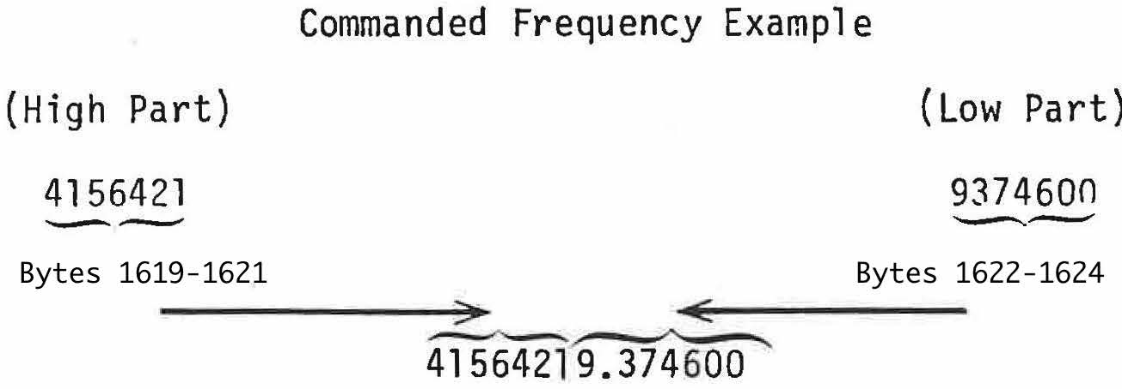
Figure 1. Reconstruction of commanded frequency from its high and low parts.

- Synthesizer Count must also be reconstructed from high (bytes 1625-1627) and low (bytes 1628-1630) parts. The count is a measure of the phase to fractions of a cycle of the output of the Dana Synthesizer, which was controlled by the POCA. The Dana Synthesizer output was heterodyned to a lower frequency and the resulting phase was captured and saved in REDR records on integer seconds. The counter rolled over after 167772160 counts. See paragraphs 18 and 19 for more information.

- Ramp Start Frequency must also be reconstructed from high (bytes 1628-1630) and low (bytes 1631-1633) parts. The value is set when the Occultation Data Assembly (ODA) is started and remains unchanged for the time that the ODA runs. The timing is described in paragraph 19.

- POCA Sweep Rate (bytes 1637-1640) is a two’s complement integer which must be divided by 10⁵ to arrive at the sweep rate in Hertz/second. See paragraph 18 for the relationships among sweep rate, synthesizer count, and commanded frequency.

- POCA Status (byte 1641) is an 8-bit binary integer within which each bit indicates a POCA-related status. The bits and their meanings are shown in Table 2.

Table 2 – POCA Status
Bit | Function | Meaning of ‘1’ | Meaning of ‘0’
0 | Sweep | On* | Off
1 | Acquisition | On | Off*
2 | Track | On* | Off
3 | Limit Enable | On | Off*
4 | Synthesizer Lock | In-lock* | Out-of-lock
5 | Synthesizer Power | On* | Off
6 | Control | Ready* | Not Ready
7 | Control | Manual | Computer
* Denotes expected value for radio science operation

- Time Offset (bytes 1642-1644) includes the delay through an A/D converter and the associated logic circuitry. It is part of the total offset between the time when the first sample in a record was acquired and the time tag for the record. It is computed as follows:
Time Offset (nanoseconds) = 10⁹/(20 x sample_rate) + 460

- Sample Size (bytes 1645-1648) is the number of bits in each sample. Values of ‘8’ or ‘12’ are allowed by the REDR specifications, but only 8-bit samples were collected for Voyager Jupiter radio science.

- File Creation Date/Time (bytes 1669-1674) is the date and time the REDR was created from the DSN source tape.

- Spacecraft ID (byte 1675) is the identifier for the spacecraft (‘31’ for Voyager 1 and ‘32’ for Voyager 2).

- DSS ID (byte 1676) is the identifier for the DSN antenna through which the radio science data were collected. For Voyager 1 the value is ‘63’, and for Voyager 2 the value is ‘14’.

- File Start Date/Time (bytes 1677-1682) is a date and time near (and often slightly earlier than) the time of the first record in a file (paragraph 1). But it is not reliable; in fact, most of the File Start Seconds values from both encounters are larger than 59.

- File Stop Date/Time (bytes 1683-1688) should be a date and time near the end of the file. Most, if not all, of the values found from both encounters have ‘0’ in all date and time fields.

- PREDIK Set ID is a string of 4 ASCII characters identifying the set of predicts used to acquire the radio science data. The value for Voyager 1 is ‘VG13’, and the value for Voyager 2 is ‘VBU1’. Users of these data are not likely to find predicts to be helpful in analysis, and no predicts were available for the archive.

- The Commanded Frequency, Synthesizer Count, and POCA Sweep Rate are related as follows (see Figure 2):
Cf_{t} = 40 x 10⁶ + [ (O_{t+n} – O_{t} - 0.5 x SR x n²)/n]
where
Cf_{t} = Commanded Frequency at time t
O_{t+n} = Synthesizer Count at t+n seconds
SR = POCA Sweep Rate in Hertz/second
n = time in seconds between sample O_{t+n} and sample O_{t}
The error between Synthesizer Count and Commanded Frequency is on the order of tenths of a Hertz at S-band.

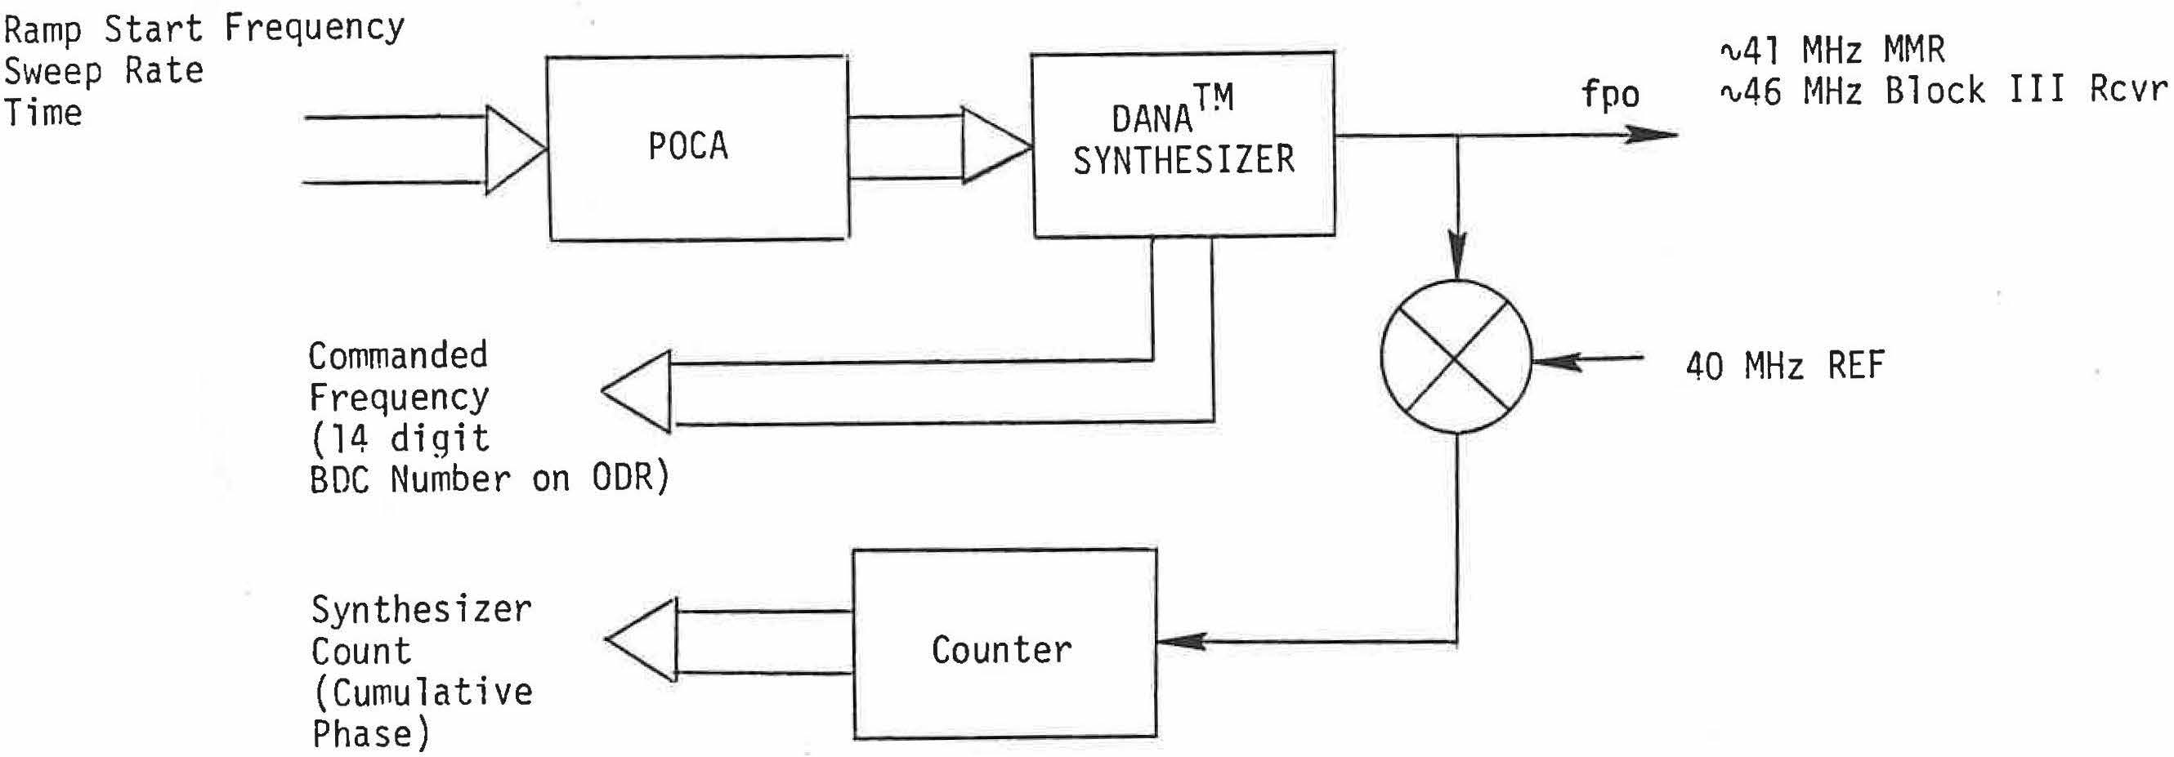
Figure 2. POCA frequency and Synthesizer Count flow.

- The relationship between the Record Date/Time and the actual time of the first sample in a record is given below. This correction should be added to the Record Date/Time as follows:
Actual Sample Time = Record Time (bytes 1-7) +
1 second +
1 sample interval (inverse of bytes 9-12) +
Time Offset (bytes 1642-1644)

