DOCUMENT 820-13; Rev. A
DSN SYSTEM REQUIREMENTS
DETAILED INTERFACE DESIGN

RSC-11-1
DSN RADIO SCIENCE SUBSYSTEM INTERFACE
CTA 21 OUTPUT

(Insert this modular document in 820-13; Rev. A)

EFFECTIVE DATE: 15 August 1978 Effective Service: Pioneer Venus 78
Initial Release Date: 15 January 1978
Approved by:
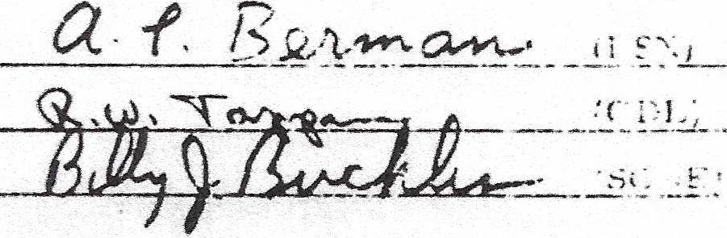

A. PURPOSE.

This document defines and controls the formats of the CTA 21 Radio Science Subsystem (CRS) format.

B. REVISION AND CONTROL.

Revision or changes to the information herein presented may be initiated according to the procedures in Section I of this document.

C. GENERAL INFORMATION.

The CRS block is generated during the Pioneer Venus 78 multiprobe mission. The block format is shown in Figure RSC-11-1-1.

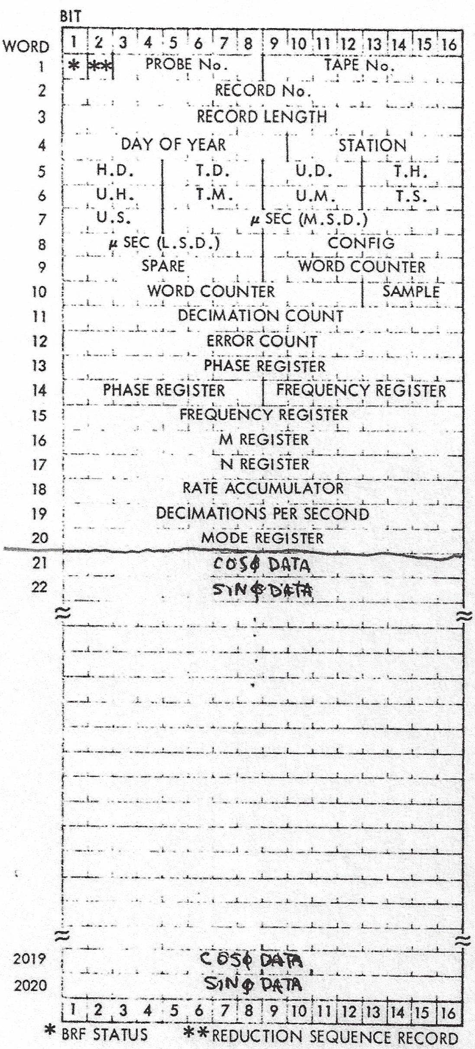
Figure RSC-11-1-1. Wideband (WB) Radio Science Intermediate Data Record (IDR) Block Format

D. WIDEBAND RADIO SCIENCE IDR BLOCK FORMAT

The IDR block format shown in Figure RSC-11-1-1 is described word by word here (reference module IDR-12-2 of this document for IDR format).

Word 1, bit 1. Bandpass reduction filter (BRF) status:

1 = Valid
0 = Invalid

Word 1, bit 2. Reduction sequence record:

1 = First record of a new sequence
0 = Not the first record

Word 1, bits 3-8: Number of the spacecraft probe (binary).

Word 1, bits 9-16. Tape number (binary).

Word 2, bits 1-16. Record number (binary).

Word 3, bits 9-16. Record length in number of 16-bit words (binary).

Word 4, bits 1-9. Date (1 through 366) data were reduced (binary).

Word 4, bits 10-16. Station recording data

Words 5 through 20, bits 1-16. BRF status as follows:

Word 5, bits 1-4. Hundreds digit of days.

Word 5, bits 5-8. Tens digit of days.

Word 5, bits 9-12. Units digit of days.

Word 5, bits 13-16. Tens digit of hours.

Word 6, bits 1-4. Units digit of hours.

Word 6, bits 5-8. Tens digit of minutes.

Word 6, bits 9-12. Units digit of minutes.

Word 6, bits 13-16. Tens digit of seconds.

Word 7, bits 1-4. Units digit of seconds.

Word 7, bits 5-16. Microseconds most significant bits (binary).

Word 8, bits 1-8. Microseconds least significant bits (binary)

Word 8, bit 9. Housekeeping channel sync:
1 = Out of sync
0 = In sync

Word 8, bit 10. Input select monitor:
1 = Invalid
0 = Valid

Word 8, bit 11. Recorder select:
1 = A
0 = B

Word 8, bit 12. Clock sync:
1 = Out of sync
0 = Sync

Word 8, bit 13. 1 pulse per second:
1 = Absent
0 = Present

Word 8, bits 14-16. Input selection:
0 = input 1
1 = input 2
2 = input 3
3 = input 4
4 = Test

Word 9, bits 1-8. Spare

Word 9, bits 9-15. BRF WB recorder word counter most significant bits (binary).

Word 10, bits 1-12. BRF WB recorder word counter least significant bits (binary).

Word 10, bits 13-16. BRF sample count (binary).

Word 11, bits 1-16. Decimation count (number of samples – binary).

Word 12, bits 1-16. Error (magnetic tape) count (binary).

Word 13, bits 1-16. BRF phase register most significant bits (binary).

Word 14, bits 1-8. BRF phase register least significant bits (binary).

Word 14, bits 9-16. BRF frequency register most significant bits (binary).

Word 15, bits 1-16. BRF frequency register least significant bits (binary).

Word 16, bits 1-16. BRF M register (binary).

Word 17, bits 1-16. BRF N register (binary).

Word 18, bits 1-16. BRF rate accumulator (binary).

Word 19, bits 1-16. Number of decimations per BRF pseudo-second (binary).

Word 20, bits 1-16. Mode register as follows:

Bit 1. Timing track select
0 = Track 22
1 = Track 23

Bit 2. Parity sense
0 = Normal
1 = Inverted

Bits 3-4. Playback speed
0 = 4.16 MHz
1 = 2.08 MHz
2 = 1.04 MHz
3 = .52 MHz

Bits 5-8. Spare

Bit 9. Data source
0 = Tape
1 = Test

Bits 10-12. Test data (9 is most significant bit)

Bit 13. Time input enable
0 = With parity
1 = Without parity

Bits 14-16. Spare

Word 21, bits 1-16. ΣF cos Φ data accumulations (binary) – real

Word 21, bits 1-16. ΣF sin Φ data accumulations (binary) – imaginary

Words 23 through 2020. Update to words 21 and 22 in sequence. Data from words 21 and 22 from the first record are used as the data base for all data accumulated.

APPENDIX A

- The time tags of the Wideband Radio Science Data on the reduced bandwidth tapes are related to the station clock time (and the data samples) as follows:

T_{s} = 180 + TT + [180/125]*WC + [180/750]*SC + 2.96 microseconds
where:

T_{s} = Time of the first cos/sin Pair in the record. It is the time corresponding to the end of the decimation period that produced the pair.

TT = Tape time in the record header

WC = Word count value

SC = Sample counter value

180 = Delay in time input from the Wideband Tape (1 frame)

2.96 = Delay of the time with respect to the data in the DRA and BRF

A brief description of the parameters involved in the time tags follows:

- Wideband Tape Format

The digital wideband tape is formatted to record six data samples in parallel across the tape. Each set of six samples comprises one data word. A frame contains 125 words or 750 data samples. A serial timing track is recorded in addition to the data. It contains the time tag of sample No. 6 in the frame. This time tag has a fixed delay of 5.12 microseconds. The serial time is clocked into a parallel register at the end of each frame for input into the computer. This results in the time tag lagging the data by one frame, or 180 microseconds since the samples are taken at a rate of 4 1/6 MHz (0.24 microsecond per second).

- Word Count and Sample Count

A Word Counter counts the number of data words that have been processed since the last valid time was entered into the parallel time register. A sample counter counts the number of data samples that have been processed in the next data word. These two counters indicate the fraction of a frame that has been processed since the last update of the parallel time register.

The word counter’s contribution to the time is:

(180/125)*WC (microseconds)

The sample counter’s contribution is:

(180/750)*SC (microseconds)

It should be noted that the clocking of the serial time register into the parallel time register occurs at the beginning of Word 1 (Word Count = 1). The data analysis program must therefore replace any occurrence of Word Counter = 0 with Word Counter = 125 in order to maintain the correct data/time relationship.

- Tape Time/Data Delay

The Digital Recording Assembly (DRA) and BRF combine to delay the time tagging of the reduced bandwidth tapes by 2.96 μsec with respect to the data samples, as follows:

The DRA has a built-in delay of 5.12 μsec in the timing channel to allow the BCD time to stabilize prior to sampling. The data are delayed by six sample times (1.44 μsec) by sampling and multiplexing prior to being written on tape. The net time delay is therefore 3.68 μsec, referenced to sample number one in the frame. The data clocking in the BRF delays the samples by three sample times with respect to the time input, resulting in a 2.96 microsecond delay with respect to the data.

- The first item of the “Sample Pair” is “real” and the second item is “imaginary”, as indicated by the folloωing.

Assume a data input of sin ωt and local oscillator signals of sin ω_{o}t and cos ω_{o}t. The outputs of the BRF multiplier are:

(sin ωt)*(cos ω_{o}t) = (1/2)sin(ω-ω_{o})t
(sin ωt)*(sin ω_{o}t) = (1/2)cos((ω-ω_{o})t

assuming that the (ω+ω_{o}) terms are removed by the lowpass filter.

Relating this to the circular function e^{iθ} = cosθ +i*sinθ, we have:

e^{iθ} = (1/2)cos(ω-ω_{o})t +i*(1/2)sin((ω-ω_{o})t

The first item of the sample pair is the sin function of the local oscillator, making the first item “real” and the second item “imaginary”.

This is a complete revision of Module RSC-11-1
That is, 820-13; Rev. A
That is, 820-13; Rev. A
Reference Appendix A
Reference Appendix A
Reference Appendix A
Handwritten note added to the Voyager document, presumably by Buckles: “Please note that the 180 μsec/frame is the Pioneer Venus sample rate. Voyager is 46.875 μsec/frame.”

