Interpretation and Use of Binary RSC-11-10A Data
This document describes and illustrates extraction of values from binary files generated according to the NASA Deep Space Network (DSN) RSC-11-10A Software Interface Specification (SIS). In this document, RSC-11-10A is referenced as:
[1] Document 820-013 (Rev. A), DSN System Requirements, Detailed Interface Design,
RSC-11-10A, Voyager Neptune ODR Agreement, effective date July 1988 (PDS logical identifier urn:nasa:pds:radiosci.documentation:dsn.rsc-11-10a:1988-07-01)
RSC-11-10A is one of several modules within DSN 820-013 that governed generation of open loop radio science raw data products over about two decades starting in the late 1970s. RSC-11-10A specifies the format and content of the open loop radio science files collected using the 70-m NASA Deep Space Network antenna near Canberra, Australia, during the Voyager 2 encounter with Neptune. Variations of this format, used for collection of data during the same encounter at Parkes Observatory (Australia) and the Usuda Tracking Station (Japan), are described separately.
Data Overview:
Digital open loop data were the primary inputs for the study of radio occultations by the neutral atmosphere and ionosphere of Neptune and by the ionosphere of Triton.
The data were generated by the Spectrum Processing Assembly (SPA) of the Deep Space Communications Complex (DSCC) Spectrum Processing Subsystem (DSP), using radio science software of the DSP, designated “DSP-R”.
During the Neptune encounter, S- and X-band receiver outputs in right-circular polarization (RCP) from the 70-m antenna (DSS-43) at the DSCC near Canberra, Australia, were written to tape at 100,000 8-bit (real) samples per second from each of the two receiver channels. The X-RCP receiver output was sampled alternately by analog-to-digital converters (ADCs) AD1 and AD3. The S-RCP receiver output was sampled alternately by AD2 and AD4. Each ADC operated at 50,000 samples per second; AD2 and AD4 were delayed by 10 μs relative to AD1 and AD3, yielding an effective rate of 100,000/s for each receiver.
Table 1 shows the Neptune occultation timeline, significant events, and corresponding tape numbers (column 6). Table 2 provides the same information with events before, during, and after the Triton occultation.
The data were originally distributed on Computer-Compatible Tapes (CCTs). In the mid-1990s the tape data were copied to CD-ROM volumes, and in 2020 the CD-ROMs were copied to a laptop computer. Subsequent handling has exclusively used the electronic (laptop) files. Throughout, [1] has remained the descriptive document of the Canberra data.

Event Time (UTC) | Event | Tape Start (s) | Tape State (UTC) | Tape Stop (UTC) | Tape NC | Notes
 |  | 09302 | 02:35:02 | 02:38:03 | 0590 | Test
 |  | 09722 | 02:42:02 | 02:50:00 | 0591 | Test
 |  | 11522 | 03:12:02 | 03:20:02 | 0592 | Test
 |  | 12002 | 03:20:02 | 03:28:01 | 0593 | Test
06:40:02 | Begin recording of Neptune occultation | 24002 | 06:40:02 | 06:48:02 | 0594
 |  | 24482 | 06:48:02 | 06:56:02 | 0595
06:59:09  07:01:02  07:02:02 | Inbound ring plane crossing  S-band telemetry OFF  X-band telemetry OFF | 24962 | 06:56:02 | 07:04:02 | 0596
07:06:02  07:11:25 | Start roll to Canopus  End roll to Canopus | 25442 | 07:04:02 | 07:12:02 | 0597
07:14:52 | Begin Mini-ASCAL | 25922 | 07:12:02 | 07:20:02 | 0598
07:22:53  07:26:03 | End Mini-ASCAL  TWNC OFF | 26402 | 07:20:02 | 07:28:02 | 0599
 |  | 26882 | 07:28:02 | 07:36:02 | 0600
07:42:03 | TWNC ON | 27362 | 07:36:02 | 07:44:02 | 0601
 |  | 27842 | 07:44:02 | 07:52:02 | 0602
 |  | 28322 | 07:52:02 | 08:00:02 | 0603
08:07:57 | Begin limbtrack maneuver | 28802 | 08:00:02 | 08:08:02 | 0604
 |  | 29282 | 08:08:02 | 08:16:02 | 0605
 |  | 29762 | 08:16:02 | 08:24:02 | 0606
 |  | 30242 | 08:24:02 | 08:32:02 | 0607
 |  | 30722 | 08:32:02 | 08:40:02 | 0608
 |  | 31202 | 08:40:02 | 08:48:02 | 0609
 |  | 31682 | 08:48:02 | 08:56:02 | 0610
08:56:54 | End limbtrack maneuver | 32162 | 08:56:02 | 09:04:02 | 0611
 |  | 32642 | 09:04:02 | 09:12:02 | 0612
 |  | 33122 | 09:12:02 | 09:20:02 | 0613
09:20:59  09:24:30 | Outbound ring plane crossing  Begin Mini-ASCAL | 33602 | 09:20:02 | 09:28:02 | 0614
09:32:30 | End Mini-ASCAL | 34082 | 09:28:02 | 09:36:02 | 0615
09:38:04  09:39:04  09:39:54  09:43:42 | X-band telemetry ON  S-band telemetry ON  Begin IMC  End IMC | 34562 | 09:36:02 | 09:44:02 | 0616
09:51:40 | Begin roll to Alkaid | 35042 | 09:44:02 | 09:52:02 | 0617
10:00:00 | Return to normal subreflector focusing | 35522 | 09:52:02 | 10:00:02 | 0618
10:02:24  10:05:16  10:06:61 | End roll to Alkaid  Real-time TWNC OFF  Begin IMC | 36002 | 10:00:02 | 10:08:02 | 0619
 |  | 36482 | 10:08:02 | 10:16:02 | 0620
 |  | 36962 | 10:16:02 | 10:24:02 | 0621
10:30:04 | TWNC ON | 37442 | 10:24:02 | 10:32:02 | 0622
10:32:28  10:36:06 | End IMC  Begin NIMC | 37922 | 10:32:02 | 10:40:02 | 0623
 |  | 38402 | 10:40:02 | 10:48:02 | 0624
10:55:01 | End recording of Neptune occultation | 38882 | 10:48:02 | 10:55:01 | 0625
Table 1. Voyager 2 Neptune occultation time line with open loop data tape numbers (column 6).

Event Time (UTC) | Event | Tape Start (s) | Tape State (UTC) | Tape Stop (UTC) | Tape NC | Notes
12:20:02 | Begin recording of Triton occultation | 44402 | 12:20:02 | 12:28:02 | 0626
 |  | 44882 | 12:28:02 | 12:36:02 | 0627
 |  | 45362 | 12:36:02 | 12:44:02 | 0628
 |  | 45842 | 12:44:02 | 12:52:02 | 0629
 |  | 46322 | 12:52:02 | 13:00:02 | 0630
 |  | 46802 | 13:00:02 | 13:08:02 | 0631
 |  | 47282 | 13:08:02 | 13:16:02 | 0632
 |  | 47762 | 13:16:02 | 13:24:02 | 0633
13:28:45  13:29:45 | S-band telemetry OFF  X-band telemetry OFF | 48242 | 13:24:02 | 13:32:02 | 0634
 |  | 48722 | 13:32:02 | 13:40:02 | 0635
13:45:26 | Begin Triton occultation | 49202 | 13:40:02 | 13:48:02 | 0636
13:48:26 | End Triton occultation | 49682 | 13:48:02 | 13:56:02 | 0637
 |  | 50162 | 13:56:02 | 14:04:02 | 0638
14:05:46  14:06:46 | X-band telemetry ON  S-band telemetry ON | 50642 | 14:04:02 | 14:12:02 | 0639
 |  | 51122 | 14:12:02 | 14:20:02 | 0640
 |  | 51602 | 14:20:02 | 14:28:02 | 0641
 |  | 52082 | 14:28:02 | 14:36:02 | 0642
 |  | 52562 | 14:36:02 | 14:44:02 | 0643
 |  | 53042 | 14:44:02 | 14:52:02 | 0644
 |  | 53522 | 14:52:02 | 15:00:02 | 0645
 |  | 54002 | 15:00:02 | 15:08:02 | 0646
 |  | 54482 | 15:08:02 | 15:16:02 | 0647
 |  | 54962 | 15:15:02 | 15:24:00 | 0648
 |  | 55442 | 15:24:02 | 15:32:02 | 0649
 |  | 55922 | 15:32:02 | 15:40:02 | 0650
 |  | 56402 | 15:40:02 | 15:48:02 | 0651
 |  | 56882 | 15:48:02 | 15:56:02 | 0652
 |  | 57362 | 15:56:02 | 16:04:02 | 0653
 |  | 57842 | 16:04:02 | 16:12:02 | 0654
 |  | 58322 | 16:12:02 | 16:20:02 | 0655
16:28:02 | End recording of Triton occultation | 58802 | 16:20:02 | 16:28:02 | 0656
 |  | 59282 | 17:00:00 | 17:05:00 | 0657 | Test
 |  | 59762 | 17:10:00 | 17:15:00 | 0658 | Test
Table 2. Voyager 2 Triton occultation time line with open loop data tape numbers (column 6).
File and Record Formats:
A typical tape contains a 32-byte tape header followed by 8 minutes of data in 24000 data records of 4166 bytes each. Each data record comprises 166 bytes of header data (Figure 1) and 4000 8-bit receiver samples (Figure 2). An example of RSC-11-10A binary data accompanies this document in the PDS4 archive; also included are translations of the binary to ASCII.
Important: RSC-11-10A binary data were written in “most significant byte” (MSB) first order. Most contemporary computers (ca. 2025) store and read numbers in “least significant byte” (LSB) order, so it is important to handle original RSC-11-10A data at the byte level to prevent corruption of values by unintentional “byte swapping”.
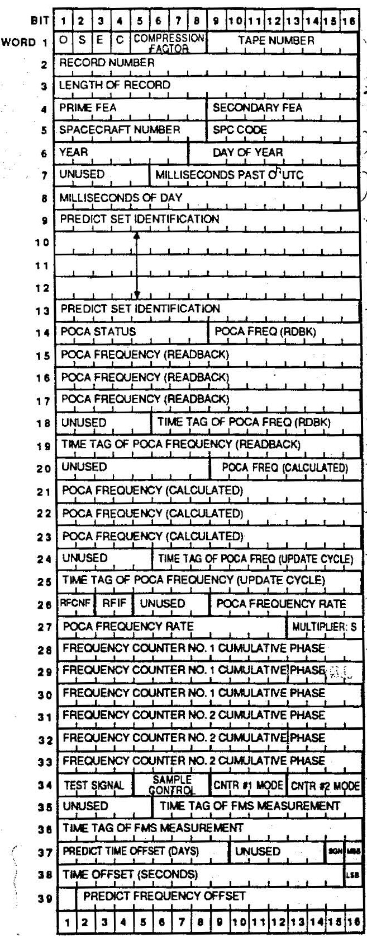
Figure 1a. Structure of RSC-11-10A record header (Words 1-39).
One 16-bit word (left margin) is two 8-bit bytes.
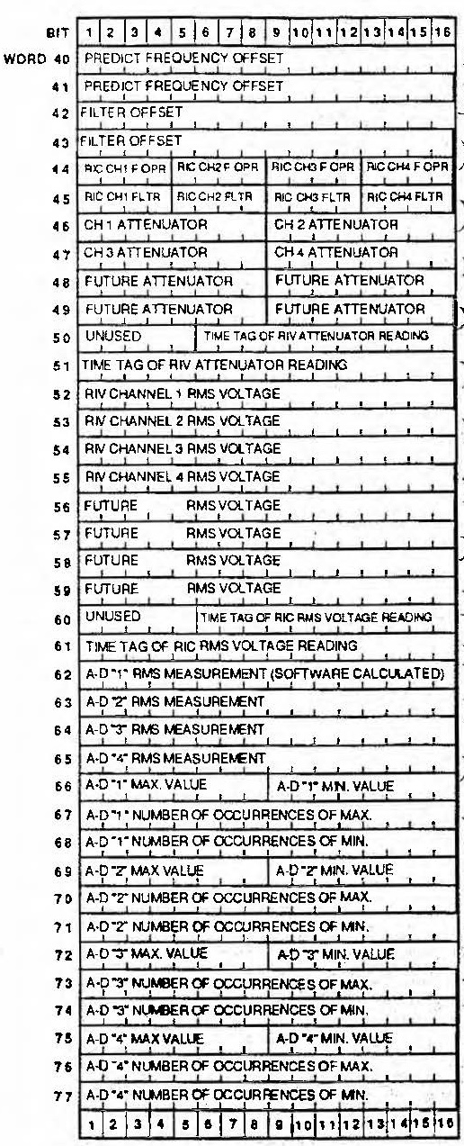
Figure 1b. Structure of RSC-11-10A record header (Words 40-77).
One 16-bit word (left margin) is two 8-bit bytes.

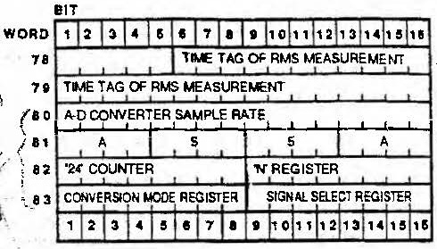
Figure 1c. Structure of RSC-11-10A record header (Words 78-83).
One 16-bit word (left margin) is two 8-bit bytes.

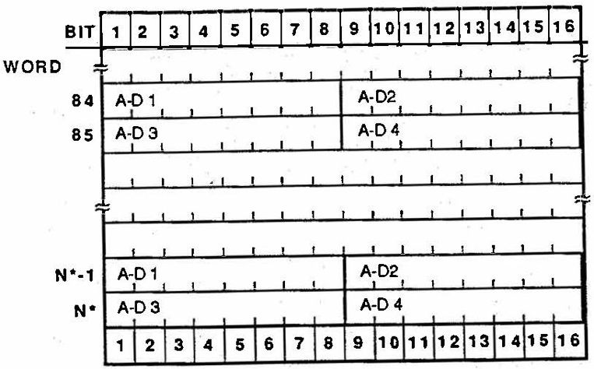
Figure 2. Structure of the data portion of RSC-11-10A records. The record header ends at Word 83 For Voyager 2 at Neptune, receiver samples were 8-bits and N=2083. Each 16-bit word (left margin) is two 8-bit bytes.

Example Data File:
An example of RSC-11-10A data (nc0590a.dat) generated at Canberra during the Voyager 2 encounter with Neptune accompanies this document. The example file is a truncated version of original file NC0590, shown starting at 02:35:02 in Table 1. Figure 3 shows the first 240 bytes in hexadecimal format from the unix-like command
od -t x1 nc0590a.dat +0. | head -15

0000000 44 53 50 52 2d 35 32 30 35 2d 4f 50 2d 44 2d 56
0000016 37 2e 31 33 00 00 00 00 00 00 00 00 00 00 00 00
0000032 d1 01 00 01 08 23 28 00 20 28 b2 ed 00 8d ef f0
0000048 54 45 53 54 2a 31 20 20 41 20 75 43 29 79 11 84
0000064 84 84 00 8d ec 08 00 43 29 79 11 84 84 84 00 8d
0000080 ec 26 00 00 00 01 79 3d bc ce 50 00 69 3d bc cc
0000096 50 00 11 10 00 8d ef fa 00 00 00 00 00 00 00 00
0000112 00 00 ff fe d9 bb 33 33 33 66 30 30 6f 75 00 00
0000128 00 00 00 8d 8c f4 01 dd 03 2a 00 02 00 05 00 00
0000144 00 00 00 00 00 00 00 8d 8c f4 05 6b 04 48 05 87
0000160 04 7b f1 1b 00 01 00 01 d8 2f 00 01 00 01 e9 16
0000176 00 01 00 01 db 28 00 01 00 01 00 8d ec 08 c3 50
0000192 a5 5a 0e fa 36 11 49 8f 72 50 a8 9c 83 67 39 6f
0000208 78 89 98 67 95 79 2c 85 86 81 a3 75 99 96 8b 9b
0000224 7b 93 84 67 bc b9 73 67 51 78 89 75 9a 7a 80 67
Figure 3. Hexadecimal dump of the first 240 bytes from file nc0590a.dat. The byte counter along the left margin is in decimal. The first 32 bytes (yellow highlighting) contain the tape header, the next 166 bytes (green highlighting) contain the first record header. The first data sample is in byte 199.
A full hexadecimal dump of the example file is available (with annotations) in nc0590a.hex.pdf
Tape Header: The 32-byte tape header is a string of ASCII characters, which translates to
DSPR-5205-OP-D-V7.13
followed by 12 ASCII null characters (0x00).
Record Headers: The first record header may be unpacked as shown in Table 3; see [1] for interpretations. Headers from all five data records are given in accompanying file nc0590a.hdr. If nc0590a.hdr were read into a spreadsheet (such as Microsoft Excel), file nc0590a.txt provides field titles which can be added to the spreadsheet.
Table 3. Unpacked Record Header from Data Record 1 (nc0590a.dat)
Bit Field | Byte Location | Bit Location (from start of record) | Value  (b = binary)  (h = hexadecimal) | Description | Unpacked Value
1 | 1 | 1 | 1_{b} | Time tag and configuration flag | 1
2 | 1 | 2 | 1_{b} | Start of recording flag | 1
3 | 1 | 3 | 0_{b} | Error flag | 0
4 | 1 | 4 | 1_{b} | Sample resolution | 0
5 | 1 | 5-8 | 1_{h} | Compression factor | 1
6 | 2 | 9-16 | 01_{h} | Tape number | 1
7 | 3-4 | 17-32 | 0001_{h} | Record number | 1
8 | 5-6 | 33-48 | 0823_{h} | Record length (words) | 2083
9 | 7 | 49-56 | 28_{h} | Prime front end area (FEA) | 40
10 | 8 | 57-64 | 00_{h} | Secondary FEA | 0
11 | 9 | 65-72 | 20_{h} | Spacecraft number | 32
12 | 10 | 73-80 | 28_{h} | Signal Processing Center (SPC) | 40
13 | 11 | 81-87 | 1011001_{b} | Year (last two digits) | 89
14 | 11-12 | 88-96 | ed_{h} | Day of year | 237
15 | 13 | 97-101 | 00_{h} | Unused 1 | 0
16 | 13-16 | 97-128 | 8deff0_{h} | Time of first sample (milliseconds past 0h UTC) | 9302000
17 | 17-26 | 129-208 | 544553542a3120204120_{h} | Predict set ID | TEST*1 A
18 | 27 | 209 | 0_{b} | POCA status (source of control) | 0
19 | 27 | 210 | 1_{b} | POCA status (readiness) | 1
20 | 27 | 211 | 1_{b} | POCA status (synthesizer power) | 1
21 | 27 | 212 | 1_{b} | POCA status (synthesizer lock status) | 1
22 | 27 | 213 | 0_{b} | POCA status (limit enable) | 0
23 | 27 | 214 | 1_{b} | POCA status (track) | 1
24 | 27 | 215 | 0_{b} | POCA status (acquisition) | 0
25 | 27 | 216 | 1_{b} | POCA status (sweep) | 1
26 | 28-34 | 217-272 | 43297911848484_{h} | POCA readback frequency (BCD, μHz) | 43297911848484
27 | 35 | 273-277 | 00_{h} | Unused 2 | 0
28 | 35-38 | 273-304 | 8dec08_{h} | FTS readback time (msec past 0h UTC) | 9301000
29 | 39 | 305-312 | 00_{h} | Unused 3 | 0
30 | 40-46 | 313-368 | 43297911848484_{h} | POCA calculated frequency (BCD, μHz) | 43297911848484
31 | 47 | 369-373 | 00_{h} | Unused 3 | 0
32 | 47-50 | 374-400 | 8dec26_{h} | Diagnostic POCA time tag (msec past 0h UTC) | 9301030
33 | 51 | 401-402 | 0_{b} | Antenna configuration code (selected) | 0
34 | 51 | 403-404 | 0_{b} | Antenna configuration code (reported) | 0
35 | 51 | 405-408 | 0_{h} | Unused 4 | 0
36 | 52-54 | 409-428 | 00000_{h} | POCA frequency rate (BCD, tenths of Hz/s) | 0
37 | 54 | 429-431 | 000_{b} | Power of 10 multiplier for POCA frequency rate | 0
38 | 54 | 432 | 1_{b} | Sign for frequency rate (0=negative, `1=positive) | 1
39 | 55-60 | 433-480 | 793dbcce5000_{h} | One-second accumulated phase #1 (2^-20 cycles) | 133306067603456
40 | 61-66 | 481-528 | 693dbccc5000_{h} | One-second accumulated phase #2 (2^-20 cycles) | 115713881427968
41 | 67 | 529-532 | 0001_{b} | FMS test facility input signal selection | 1
42-45 | 67 | 533-536 | 0001_{b} | FMS sample control register | 1
46 | 68 | 537-540 | 0001_{b} | Frequency counter 1 mode register | 1
47 | 68 | 541-544 | 0000_{b} | Frequency counter 2 mode register | 0
48 | 69 | 545-549 | 00_{h} | Unused 5 | 0
49 | 69-72 | 550-576 | 8deffa_{h} | FMS counter time tag (msec) | 9302010
50 | 73-74 | 577-585 | 000000000_{b} | Predict time offset | 0
51 | 74 | 586-590 | 00_{h} | Unused 6 | 0
52 | 74 | 591 | 0_{b} | Sign of predict time offset (1=negative, 0=positive) | 0
53 | 74-76 | 592-608 | 00000_{h} | Predict time offset (sec) | 0
54 | 77-82 | 609-656 | 000000000000_{h} | S-band predict frequency offset (2^-20 Hz) | 0
55 | 83-86 | 657-688 | fffed9bb_{h} | S-band filter offset (Hz) | -75333
56 | 87 | 689-692 | 3_{h} | RIC filter for Channel 1 (selected) | 3
57 | 87 | 691-696 | 3_{h} | RIC filter for Channel 2 (selected) | 3
58 | 88 | 697-700 | 3_{h} | RIC filter for Channel 3 (selected) | 3
59 | 88 | 701-704 | 3_{h} | RIC filter for Channel 4 (selected) | 3
60 | 89 | 705-708 | 3_{h} | RIC filter for Channel 1 (reported) | 3
61 | 89 | 709-712 | 3_{h} | RIC filter for Channel 2 (reported) | 3
62 | 90 | 713-716 | 6_{h} | RIC filter for Channel 3 (reported) | 6
63 | 90 | 717-720 | 6_{h} | RIC filter for Channel 4 (reported) | 6
64 | 91 | 721-728 | 30_{h} | RIV attenuator setting for Channel 1 (dB) | 48
65 | 92 | 729-736 | 30_{h} | RIV attenuator setting for Channel 2 (dB) | 48
66 | 93 | 737-744 | 6f_{h} | RIV attenuator setting for Channel 3 (dB) | 111
67 | 94 | 745-752 | 75 | RIV attenuator setting for Channel 4 (dB) | 117
68 | 95 | 753-760 | 00_{h} | RIV attenuator for future use | 0
69 | 96 | 761-768 | 00_{h} | RIV attenuator for future use | 0
70 | 97 | 769-776 | 00_{h} | RIV attenuator for future use | 0
71 | 98 | 777-784 | 00_{h} | RIV attenuator for future use | 0
72 | 99 | 785-789 | 00_{h} | Unused 7 | 0
73 | 99-102 | 790-816 | 8d8cf4_{h} | RIV attenuator time tag (msec) | 9276660
74 | 103-104 | 817-832 | 1dd_{h} | RIC RMS voltage, Channel 1 (mv) | 477
75 | 105-106 | 833-848 | 32a _{h} | RIC RMS voltage, Channel 2 (mv) | 810
76 | 107-108 | 849-864 | 2_{h} | RIC RMS voltage, Channel 3 (mv) | 2
77 | 109-110 | 865-880 | 5_{h} | RIC RMS voltage, Channel 4 (mv) | 5
78 | 111-112 | 881-896 | 0 | Future RMS voltage #1 | 0
79 | 113-114 | 897-912 | 0 | Future RMS voltage #2 | 0
80 | 115-116 | 913-928 | 0 | Future RMS voltage #3 | 0
81 | 117-118 | 929-944 | 0 | Future RMS voltage #4 | 0
82 | 119 | 945-949 | 0 | Unused 8 | 0
83 | 119-122 | 950-976 | 8d8cf4_{h} | RIC RMS voltage time tag (msec) | 9276660
84 | 123-124 | 977-992 | 56b_{h} | Software calculated RMS voltage, Channel 1 (mv) | 1387
85 | 125-126 | 993-1008 | 448_{h} | Software calculated RMS voltage, Channel 2 (mv) | 1096
86 | 127-128 | 1009-1024 | 587_{h} | Software calculated RMS voltage, Channel 3 (mv) | 1415
87 | 129-130 | 1025-1040 | 47b_{h} | Software calculated RMS voltage, Channel 4 (mv) | 1147
88 | 131 | 1041-1048 | f1_{h} | Maximum ADC value, Channel 1 | 241
89 | 132 | 1049-1056 | 1b_{b} | Minimum ADC value, Channel 1 | 27
90 | 133-134 | 1057-1072 | 0001_{h} | Number of occurrences of value in byte 131 | 1
91 | 135-136 | 1077-1088 | 0001_{h} | Number of occurrences of value in byte 132 | 1
92 | 137 | 1089-1096 | d8_{h} | Maximum ADC value, Channel 2 | 216
93 | 138 | 1097-1104 | 2f_{h} | Minimum ADC value, Channel 2 | 47
94 | 139-140 | 1105-1120 | 0001_{h} | Number of occurrences of value in byte 137 | 1
95 | 141-142 | 1121-1136 | 0001_{h} | Number of occurrences of value in byte 138 | 1
96 | 143 | 1137-1144 | e9_{h} | Maximum ADC value, Channel 3 | 233
97 | 144 | 1145-1152 | 16_{h} | Minimum ADC value, Channel 3 | 22
98 | 145-146 | 1153-1168 | 0001_{h} | Number of occurrences of value in byte 143 | 1
99 | 147-148 | 1169-1184 | 0001_{h} | Number of occurrences of value in byte 144 | 1
100 | 149 | 1185-1192 | db_{h} | Maximum ADC value, Channel 4 | 219
101 | 150 | 1193-1200 | 28_{h} | Minimum ADC value, Channel 4 | 40
102 | 151-152 | 1201-1216 | 0001_{h} | Number of occurrences of value in byte 149 | 1
103 | 153-154 | 1217-1232 | 0001_{h} | Number of occurrences of value in byte 150 | 1
104 | 155 | 1233-1237 | 0 | Unused 9 | 0
105 | 155-158 | 1238-1264 | 8dec08_{h} | Time tag of max-min samples (msec) | 9301000
106 | 159-160 | 1265-1280 | c350_{h} | Single ADC sample rate (samples per second) | 50000
107 | 161-162 | 1281-1296 | a55a_{h} | NBOC sync code | A55A
108 | 163 | 1297-1304 | 0e_{h} | “24” counter | 14
109 | 164 | 1305-1312 | fa_{h} | “N” register | 250
110 | 165 | 1313 | 0_{b} | NBOC overflow flag | 0
111 | 165 | 1314 | 0 | Unused 10 | 0
112 | 165 | 1315 | 1_{b} | NBOC PLL in-lock flag | 1
113 | 165 | 1316 | 1_{b} | Sample rate flag | 1
114 | 165 | 1317 | 0_{b} | Operational mode flag | 0
115 | 165 | 1318 | 1_{b} | Sample resolution flag | 1
116 | 165 | 1319-1320 | 10_{b} | Sample mode flag | 2
117 | 166 | 1321-1322 | 00_{b} | AD1 assignment | 0
118 | 166 | 1323-1324 | 01_{b} | AD2 assignment | 1
119 | 166 | 1325-1326 | 00_{b} | AD3 assignment | 0
120 | 166 | 1327-1328 | 01_{b} | AD4 assignment | 1

Data Values: The first data record in the example file includes 4000 8-bit data samples. In Figure 3, receiver samples begin with hexadecimal value 0x49 (decimal 73) in byte 199. This sample as well as the fifth, ninth, etc. came from AD1; the third, seventh, eleventh, etc. came from AD3. Together, they provide the sample stream that represents the output from the Channel 1 (X-RCP) receiver. The second, fourth, sixth, etc. samples are from AD2 and AD4; they combine to represent the output from the Channel 2 (S-RCP) receiver (see accompanying files nc0590x.tab and nc0590s.tab respectively). Figure 4 shows histograms of the sample values from the two receivers.

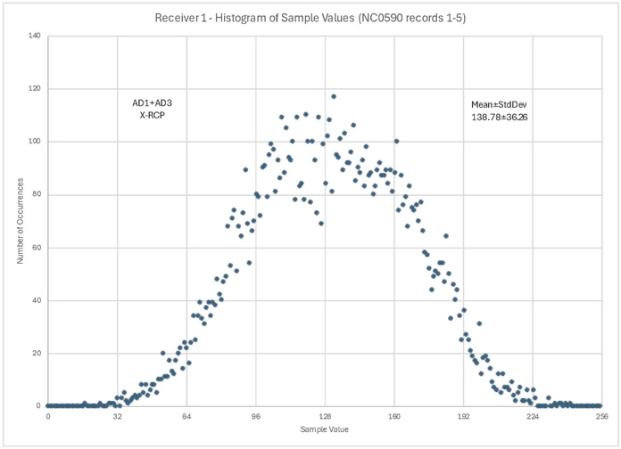
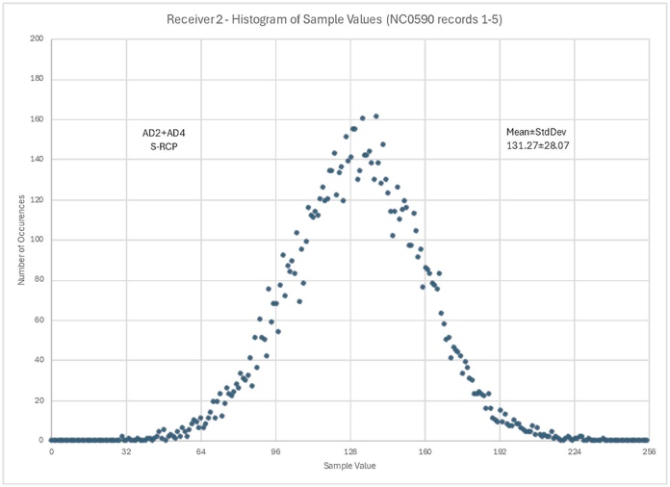
Figure 4. Histograms of the samples from each receiver in data records 1-5 of the example file (10000 samples in each histogram). Receiver 1 (X-RCP, left) is represented by samples from AD1 and AD3; Receiver 2 (S-RCP, right) is represented by samples from AD2 and AD4.

G. L. Tyler, D. N. Sweetnam, J. D. Anderson, S. E. Borutzki, J. K. Campbell, V. R. Eshleman, D. L. Gresh, E. M. Gurrola, D. P. Hinson, N. Kawashima, E. R. Kursinski, G. S. Levy, G. F. Lindal, J. R. Lyons, E. A. Marouf, P. A. Rosen, R. A. Simpson, and G. E. Wood. Voyager Radio Science Observations of Neptune and Triton, Science, 246, 1466-1473, 1989.

