Interpretation and Use of Binary RSC-11-9 Data
This document describes and illustrates extraction of values from binary files generated according to the NASA Deep Space Network (DSN) RSC-11-9 Software Interface Specification (SIS). In this document, RSC-11-9 is referenced as:
[1] Document 820-013 (Rev. A), DSN System Requirements, Detailed Interface Design,
RSC-11-9, DSN Radio Science System Interface, Original Data Record,
effective date 1 March 1985 (PDS logical identifier urn:nasa:pds:radiosci.documentation:dsn.rsc-11-9)
RSC-11-9 is one of several modules within DSN 820-013 that governed generation of open loop radio science raw data products over about two decades starting in the late 1970s. RSC-11-9 specifies the format and content of the most important open loop radio science files collected using NASA Deep Space Network antennas near Canberra, Australia, during the Voyager 2 encounter with Uranus. A variation of this format, used for collection of data during the Voyager 2 encounter with Uranus at Parkes Observatory (Australia), is described separately. Its citation differs only in the year of the effective date.
[2] Document 820-013 (Rev. A), DSN System Requirements, Detailed Interface Design, RSC-11-9, DSN Radio Science System Interface, Original Data Record, effective date 1 March 1982 (PDS logical identifier urn:nasa:pds:radiosci.documentation:dsn.rsc-11-9p)
Data Overview:
The data were originally distributed on Computer-Compatible Tapes (CCTs). In the mid-1990s the tape data were copied to CD-ROM volumes, and in 2020 the CD-ROMs were copied to a laptop. Subsequent handling has been carried out on the electronic (laptop) files. Throughout, [1] has remained the descriptive document of the Canberra data.
Open loop data were the primary inputs for the study of radio occultations by the neutral atmosphere, ionosphere, and rings of Uranus. These digital data were generated by the Spectrum Processing Assembly (SPA) of the Deep Space Communications Complex (DSCC) Spectrum Processing Subsystem (DSP), using radio science software of the DSP, designated “DSP-R”.
During the Uranus encounter, S- and X-band receiver outputs in right-circular polarization (RCP) from the 64-m antenna (DSS43) and the 34-m antenna (DSS42) at the DSCC near Canberra, Australia, were written to tape at 50000 8-bit (real) samples per second from each of the four receiver channels. Table 1 shows the Uranus encounter timeline, significant events, and the corresponding tape numbers. Table 2 lists recordings of test data.
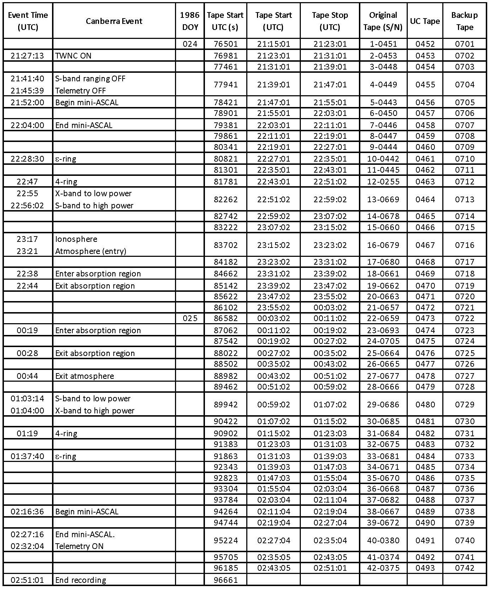
Table 1. This table lists significant radio science events during the Voyager 2 encounter with Uranus (as seen in Australia) as a function of time. Tapes which were delivered to the Voyager Radio Science Team are listed in column 8 (UC tapes). Backup tapes, created at Stanford University, are shown in column 9. Tapes containing test data are listed in Table 2.
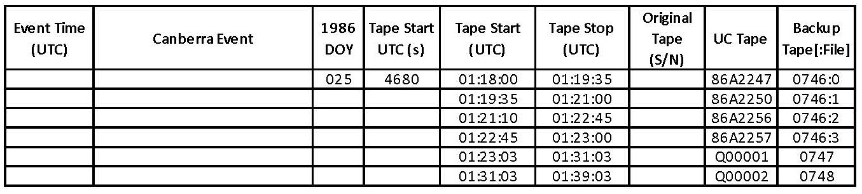
Table 2. Open loop test data collected after the Voyager 2 Uranus encounter. Tapes delivered to the Voyager Radio Science Team are listed in column 8 (UC Tape). Backup tapes, created at Stanford University, are listed in column 9. Notation mmmm:n denotes backup tape number mmmm and file number n (starting from 0).
File and Record Formats:
A typical tape contains a 32-byte tape header followed by 8 minutes of data in 24000 records of 4390 bytes each. Each data record comprises 80 bytes of header data (Figure 1), 4000 8-bit receiver samples (Figure 2), 300 bytes of Precision Power Monitor (PPM) data (Figure 3), and 10 bytes of operator-entered offsets (Figure 4). An example of RSC-11-9 binary data accompanies this document in the PDS4 archive; also included are translations of the binary to ASCII.
Important: RSC-11-9 binary data were written in “most significant byte” (MSB) first order. Most contemporary computers (ca. 2024) store and read numbers in “least significant byte” (LSB) order, so it is important to handle original RSC-11-9 data at the byte level to prevent corruption of values by unintentional “byte swapping”.
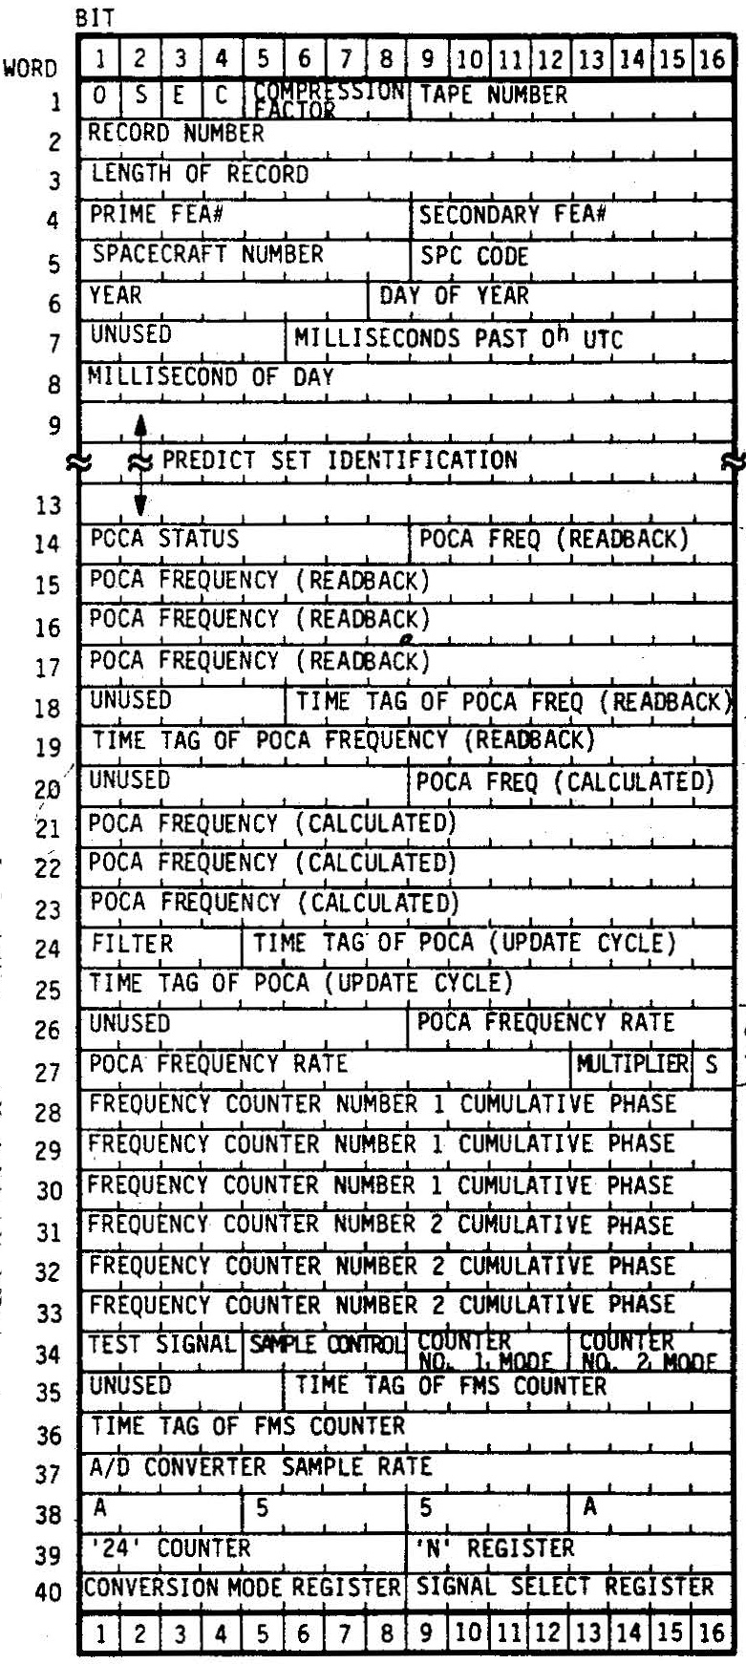
Figure 1. Structure of RSC-11-9 record header. One 16-bit word (left margin) is two 8-bit bytes.
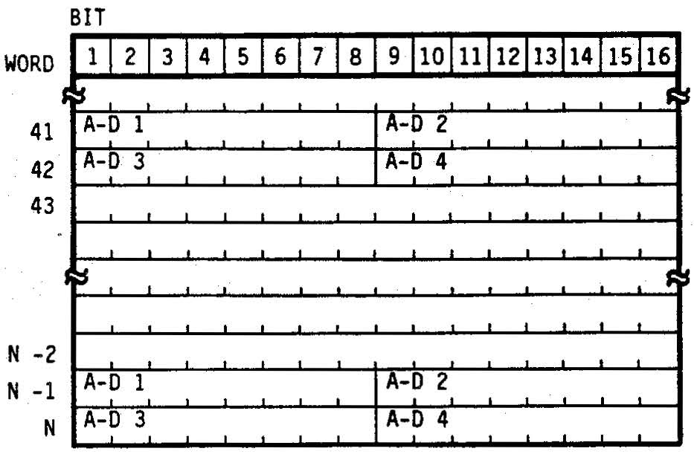
Figure 2. Structure of the RSC-11-9 data area. One 16-bit word (left margin) is two 8-bit bytes. For Voyager 2 at Uranus, the offset of the data area was N=2040 words and the analog-to-digital converter assignments were AD1=DSS-43 S-RCP, AD2=DSS-42 S-RCP, AD3=DSS-43 X-RCP, and AD4=DSS-42 X-RCP.
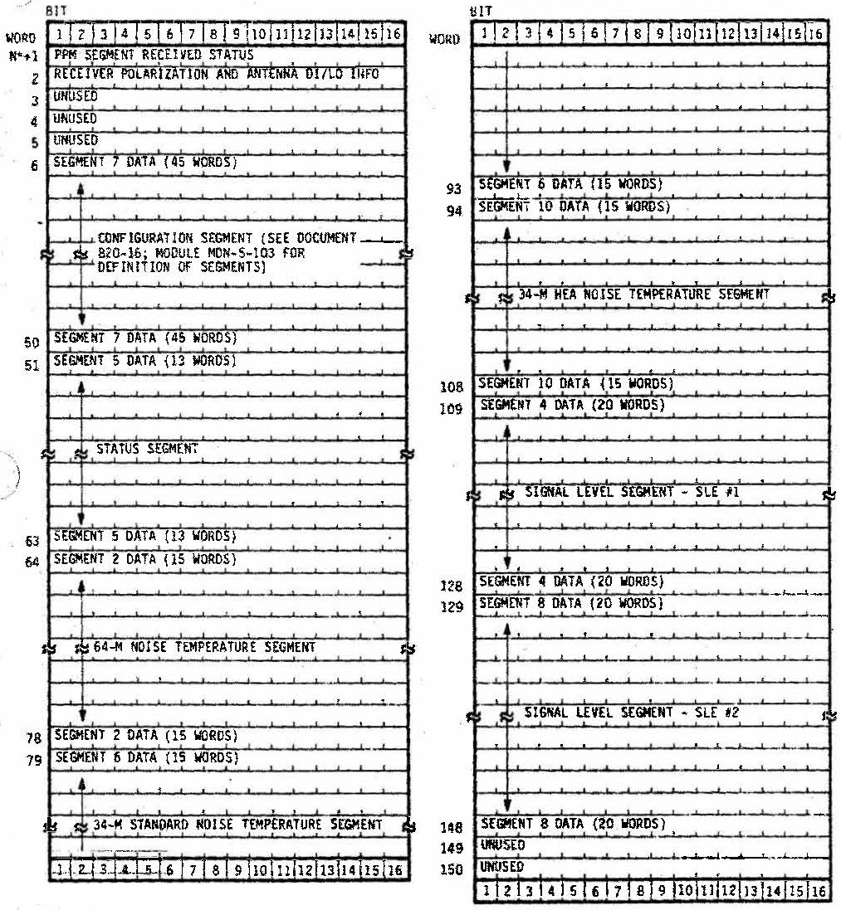
Figure 3. Structure of the RSC-11-9 PPM area. One 16-bit word (left margin) is two 8-bit bytes.
For Voyager 2 at Uranus, the offset was N=2040 words.
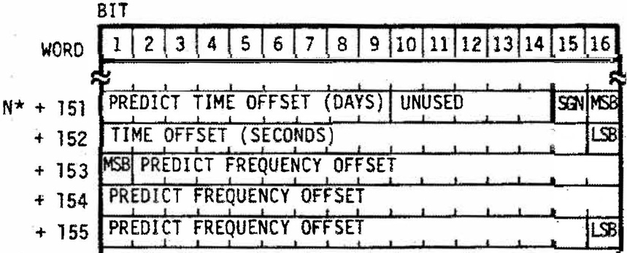
Figure 4. Structure of the RSC-11-9 operator-entered offset (OEO) area. One 16-bit word (left margin) is two 8-bit bytes. For Voyager 2 at Uranus, the offset was N=2040 words.
Example Data File:
An example of RSC-11-9 data (uc0452a.dat) generated at Canberra during the Voyager 2 encounter with Uranus accompanies this document in the PDS4 archive. Data were collected at the DSN ground station near Canberra, Australia, on 1986-024. The example file is a truncated version of original file UC0452, shown at 21:15:01 in Table 1. Figure 5 shows the first 240 bytes in hexadecimal format from the unix command
od -t x1 uc0452a.dat +0. | head -15

0000000 44 4d 4f 2d 35 32 30 35 2d 4f 50 2d 42 20 56 20
0000016 34 2e 33 20 00 00 00 00 00 00 00 00 00 00 00 00
0000032 c1 01 00 01 08 93 2b 00 20 28 ac 18 04 8f 50 08
0000048 5a 52 20 20 20 20 20 20 41 20 75 43 35 03 04 10
0000064 46 54 04 8f 50 08 00 43 35 03 04 10 61 02 84 8f
0000080 50 12 00 43 93 81 00 00 33 1f 1f e5 00 00 33 1f
0000096 1f e2 1d 10 04 8f 50 08 c3 50 a5 5a 12 f9 14 1b
0000112 8b 64 85 8a b4 94 61 89 78 8c 70 86 7c a5 95 81
0000128 aa a6 90 8a 6b 7a 82 86 6c 71 90 88 91 77 8e 8a
0000144 92 8e 9f 89 89 85 a1 8a 8e 85 93 8a 80 aa 6c 8c
0000160 b2 93 7a 87 9f 8f bb 81 77 8d 98 8c 7d 82 8f 94
0000176 7e 71 7f 8b 9c b2 77 8a 8f cf 9d 87 95 74 a7 88
0000192 8c 72 88 89 64 58 4f 8d 8b 82 80 86 71 a7 79 88
0000208 8f 6b 8b 84 b4 98 92 8d 7e 82 89 91 6e 7d a2 88
0000224 98 76 8f 87 a2 99 96 8b 8f 93 95 84 84 81 7f 8e
0000240 ...
Figure 5. Hexadecimal dump of the first 240 bytes from file uc0452a.dat. The byte counter along the left margin is given in decimal. The first 32 bytes (yellow highlighting) contain the tape header, the next 80 bytes (green highlighting) contain the first record header. The first data sample is in byte 113.
A full hexadecimal dump of the example file is available (with annotations) in uc0452a.hex.pdf
Tape Header: The 32-byte tape header is a string of ASCII characters, which translates to
DMO-5205-OP-B V 4.3
followed by one ASCII space character (0x20) and 12 ASCII null characters (0x00).
Record Headers: The first record header may be unpacked as shown in Table 3. Asterisks (*) in the right column denote flag values; see [1] for interpretations. Headers from all ten records are given in accompanying file uc0452a.hdr. If uc0452a.hdr were read into a spreadsheet (such as Microsoft Excel), file uc0452a.txt provides field headers which can be added to the spreadsheet.
Table 3. Unpacked Record Header from Data Record 1 (uc0452a.dat)
Bytes | Bit Numbers | Value  (b = binary)  (h = hexadecimal) | Description | Unpacked Value
1 | 1 | 1_{b} | Time tag and configuration flag | 1*
1 | 2 | 1_{b} | Start of recording flag | 1*
1 | 3 | 0_{b} | Error flag | 0*
1 | 4 | 0_{b} | Sample resolution | 0*
1 | 5-8 | 1_{h} | Compression factor | 1*
2 | 9-16 | 01_{h} | Tape number | 1
3-4 | 17-32 | 0001_{h} | Record number | 1
5-6 | 33-48 | 0893_{h} | Record length (words) | 2195
7 | 49-56 | 2b_{h} | Prime front end area (FEA) | 43
8 | 57-64 | 00_{h} | Secondary FEA | 0
9 | 65-72 | 20_{h} | Spacecraft number | 32
10 | 73-80 | 28_{h} | Signal Processing Center (SPC) | 40
11 | 81-87 | 56_{h} | Year (last two digits) | 86
11-12 | 88-96 | 18_{h} | Day of year | 24
13-16 | 97-128 | 048f5008_{h} | Time of first sample (milliseconds past 0h UTC) | 76501000
17-26 | 129-208 | 5a522020202020204120_{h} | Predict set ID | ZR A
27 | 209 | 0_{b} | POCA status (source of control) | 0*
27 | 210 | 1_{b} | POCA status (readiness) | 1*
27 | 211 | 1_{b} | POCA status (synthesizer power) | 1*
27 | 212 | 1_{b} | POCA status (synthesizer lock status) | 1*
27 | 213 | 0_{b} | POCA status (limit enable) | 0*
27 | 214 | 1_{b} | POCA status (track) | 1*
27 | 215 | 0_{b} | POCA status (acquisition) | 0*
27 | 216 | 1_{b} | POCA status (sweep) | 1*
28-34 | 217-272 | 43350304104654_{h} | POCA readback frequency (BCD, μHz) | 43350304104654
35-38 | 273-304 | 048f5008_{h} | FTS readback time (milliseconds past 0h UTC) | 76501000
39-46 | 305-368 | 0043350304106102_{h} | POCA calculated frequency (BCD, μHz) | 43350304106102
47 | 369-372 | 8_{h} | Receiver filter | 8
47-50 | 373-400 | 48f5012_{h} | Diagnostic POCA time tag (milliseconds past 0h UTC) | 76501010
52-54 | 409-428 | 43938_{h} | POCA rate (BCD, Hz per second) | 43938
54 | 429-431 | 000_{b} | POCA rate power of ten | 0
54 | 432 | 1_{b} | POCA rate sign | 1*
55-60 | 433-480 | 0000331f1fe5_{h} | 1-s Σ phase, counter 1 (scaled to 2⁻⁸ cycles) | 857677797
61-66 | 481-528 | 0000331f1fe2_{h} | 1-s Σ phase, counter 2 (scaled to 2⁻⁸ cycles) | 857677794
67 | 529-532 | 1_{h} | Test signal selection | 1
67 | 533-536 | d_{h} | Sample control register | 13
68 | 537-540 | 1_{h} | Frequency counter 1 mode register | 1
68 | 541-544 | 0_{h} | Frequency counter 2 mode register | 0
69-72 | 545-576 | 048f5008_{h} | FMS time tag (milliseconds past 0h UTC) | 76501000
73-74 | 577-592 | c350_{h} | Single ADC sample rate | 50000
75-76 | 593-608 | a55a_{h} | NBOC sync code | a55a_{h}
79 | 625 | 0_{b} | NBOC overflow flag | 0*
79 | 628 | 1_{b} | Sample rate flag | 1*
79 | 629 | 0_{b} | Test mode flag | 0*
79 | 630 | 1_{b} | 8-bit sample flag | 1*
79 | 631-632 | 00_{b} | ADC assignment flag | 00*
80 | 633-634 | 00_{b} | AD1 assignment | 00_{b}
80 | 635-636 | 01_{b} | AD2 assignment | 01_{b}
80 | 637-638 | 10_{b} | AD3 assignment | 10_{b}
80 | 639-640 | 11_{b} | AD4 assignment | 11_{b}

Data Values: The first record in the example file includes 4000 8-bit data samples. In Figure 5, samples begin with hexadecimal value 0x8b (decimal 139) in byte 113. This sample as well as the fifth, ninth, etc. came from AD1. The second, sixth, tenth, etc. samples came from AD2; the third, seventh, etc. came from AD3; and the fourth, eighth, etc. came from AD4 (Figure 2). If the data records are parsed in this way, the original sample stream can be recovered (see accompanying files uc0452a1.tab, uc0452a2.tab, uc0452a3.tab, and uc0452a4.tab, respectively). Figure 7 shows histograms of the sample values from each of the A-D converters in records 1-10 of the example file. Figure 8 shows power in AD outputs. Note that the histograms have similar shapes and the means are within 1 unit; but the distribution from AD4 is about 5 times narrower (and the histogram peak is about 5 time larger) than for the other three converters.
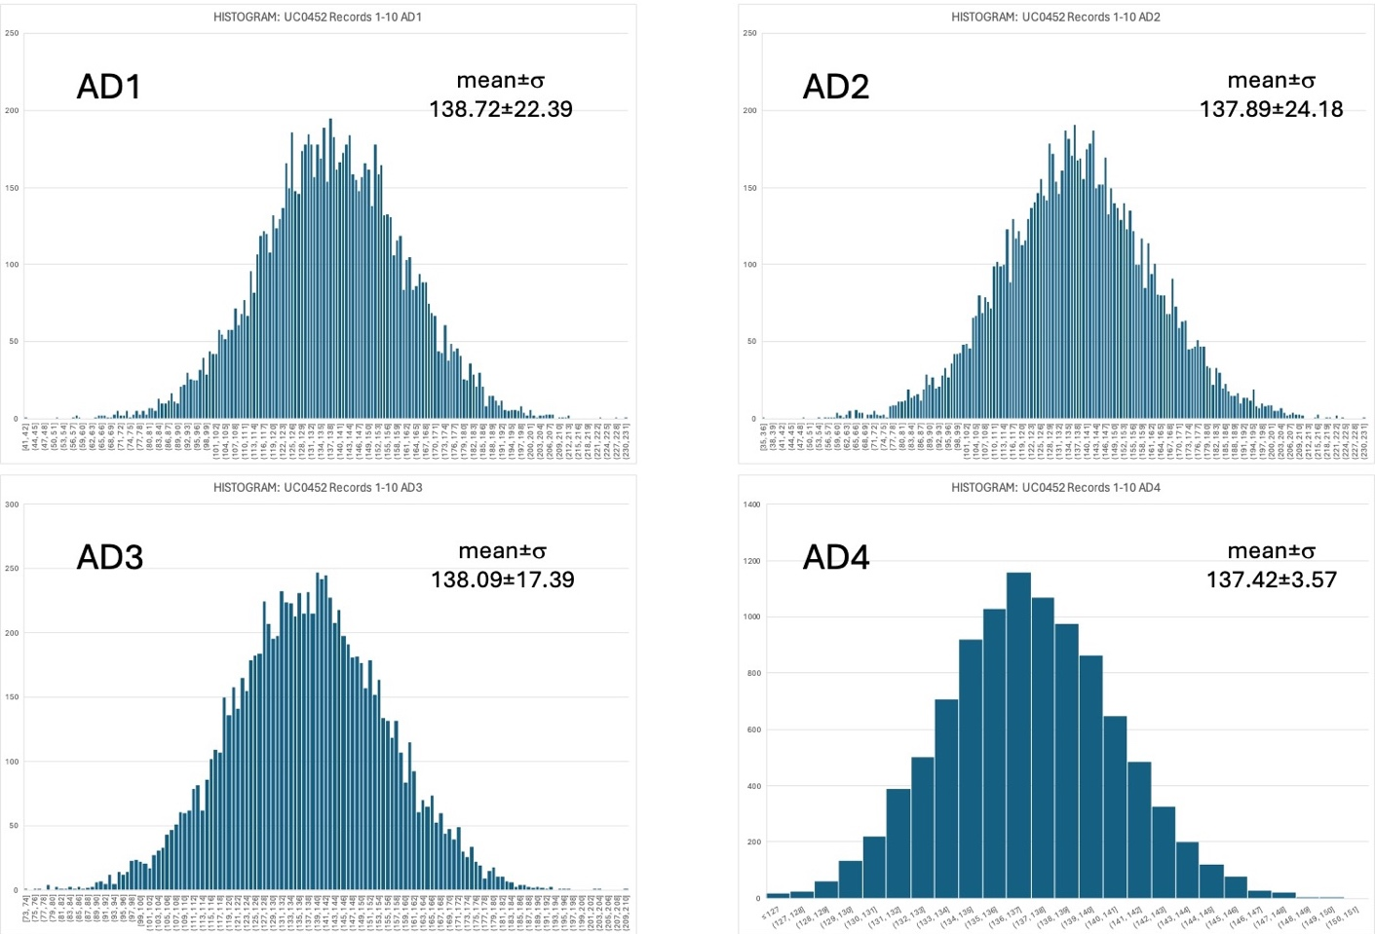
Figure 7. Histograms of the samples from each analog-to-digital converter in records 1-10 of the example file. The histograms are very similar except that the peak value for AD4 is about 5 times larger and its standard deviation is about 5 times smaller than for the other histograms.
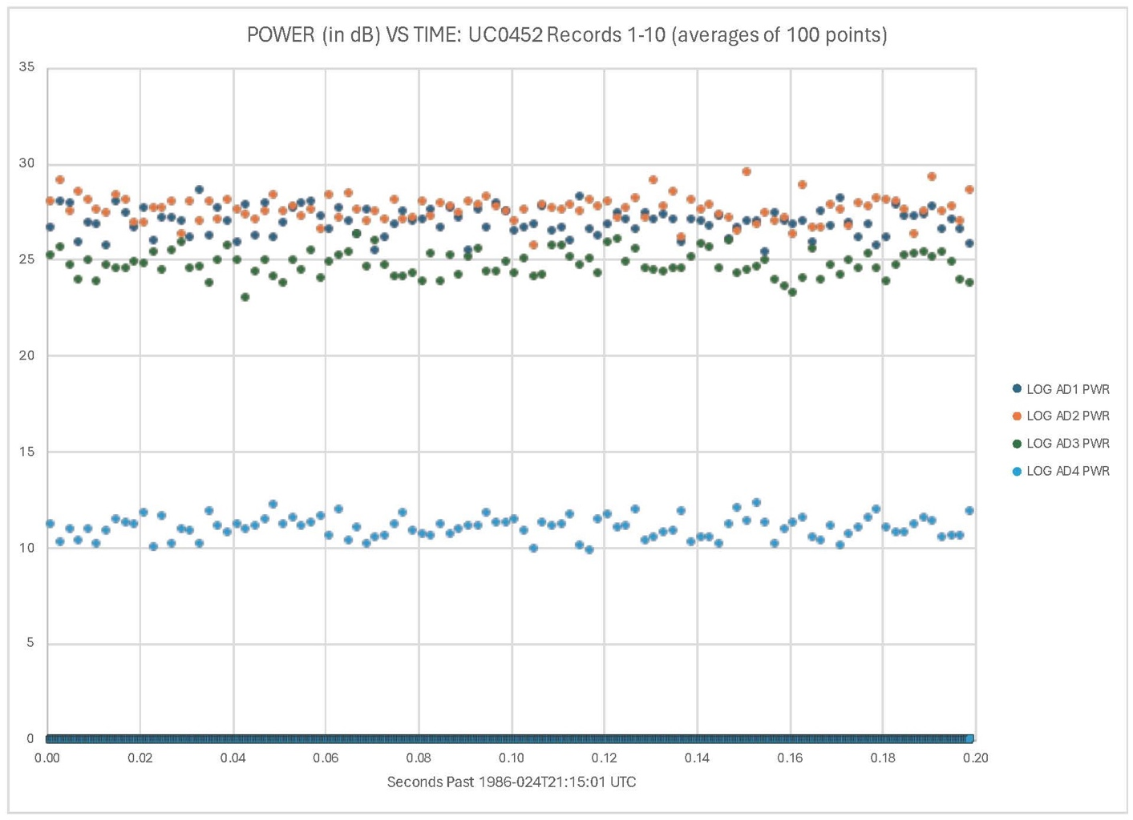
Figure 8. Power versus time in the samples from each analog-to-digital converter (ADC) versus time. Each sample value was reduced by the mean for its channel, the result was squared, and 101 such values were averaged to produce one plotted point. Sample values were extracted from the first 10 data records of UC0452; so there were 10000 original samples and 100 plotted points for each ADC.

Tapes UC0463, UC0482, UC0486, and UC0490 contain 24050 records (one extra second). Tapes UC0451 and UC0493 are short, containing 7800 and 23750 records, respectively. Tapes with test data contain variable numbers of records.
The expected value in this field is hexadecimal b_{h} or decimal 11 [1].

