**Interpretation and Use of Binary RSC-11-9 (Parkes) Data**

This document describes and illustrates extraction of values from binary files generated according to the NASA Deep Space Network (DSN) RSC-11-9 Software Interface Specification (SIS) that was used for radio science open loop data acquisition during the Voyager 2 encounter with Uranus in 1986 at Parkes Observatory (Australia). It may also apply to data collected during the Voyager 2 encounter with Neptune in 1989 at both Parkes and the Usuda Tracking Station (Japan). In this document, RSC-11-9 (Parkes) is referenced as:

[1] *Document 820-013 (Rev. A), DSN System Requirements, Detailed Interface Design,   
RSC-11-9, DSN Radio Science System Interface, Original Data Record,*   
effective date 1 March 1982.

RSC-11-9 is one of several modules within DSN 820-013 that documented generation of open loop radio science raw data products starting in the 1970s. Note that this version of RSC-11-9 is distinguished from the version dated 1 March 1985 [2], which governed data collection during 1986 and 1989 at NASA’s Canberra Deep Space Communications Complex.

[2] *Document 820-013 (Rev. A), DSN System Requirements, Detailed Interface Design,   
RSC-11-9, DSN Radio Science System Interface, Original Data Record,*   
effective date 1 March 1985.

Document [1] may sometimes be referenced as RSC-11-9P and the data may be described as having the Parkes Original Data Record (PODR) format.

**Data Overview:**

PODR data were originally distributed on Computer-Compatible Tapes (CCTs). In the mid-1990s the tape data were copied to CD-ROM volumes, and in 2020 the CD-ROMs were copied to a laptop. Subsequent handling has been carried out on the electronic (laptop) files. Throughout, [1] has remained the descriptive document.

Open loop data were the primary inputs for the study of radio occultations by the neutral atmosphere, ionosphere, and rings of Uranus. These data were generated by the Spectrum Processing Assembly (SPA) of the Deep Space Communications Complex (DSCC) Spectrum Processing Subsystem (DSP), using radio science software of the DSP, designated “DSP-R”.

During the Uranus encounter, X-band receiver outputs in right-circular polarization (RCP) from the 64-m antenna at Parkes Observatory were written to tape at 80000 8-bit samples per second (20000 per second sequentially from four analog to digital converters). Figure 1 shows the Uranus encounter timeline, significant events, and the corresponding tape numbers. Figure 2 lists recordings of test data.

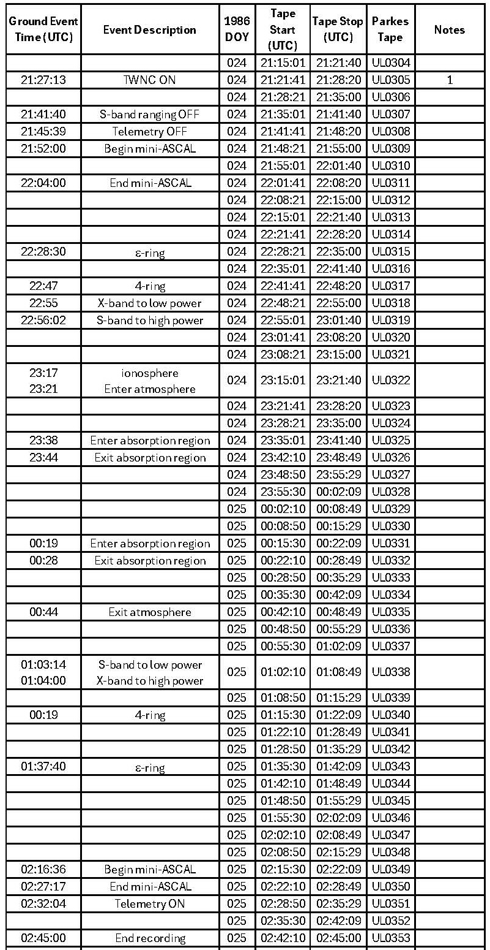  
Figure 1. Significant radio science events during the Voyager 2 encounter with Uranus (as seen at Parkes). Tape start and stop times are given in columns 4 and 5; Parkes tape numbers are in column 6. Note 1: Record 4 on the original tape was short; it was padded to the correct length, and a corrected version is included in the PDS4 archive under the file name ul0305.dat.

Figure 2. Open loop test data collected before the Voyager 2 Uranus encounter. Tapes delivered to the Voyager Radio Science Team are listed in column 6 (Parkes Tape). Note 2: Record 4 on the original tape was short; it was padded to the correct length and a correct version of the binary file is included in the archive under the file name ul0355a.dat.

**File and Record Formats:**

A typical PODR tape contained 8000 records of 4090 bytes, representing 400 seconds of receiver output. Each data record comprised 56 bytes of header data (Figure 3), 4000 8-bit receiver samples, and 34 bytes which were undefined for the Uranus observations.

Figure 3. Structure of the PODR record; field definitions are given in [1]. One 16-bit word (left margin) is two 8-bit bytes. The record header occupies words 1-28. Receiver samples then fill the next 2000 words. The final 17 words were undefined for the Voyager 2 Uranus encounter at Parkes.

**Example Data File:**

The first 10 records from tape UL0305 have been archived with this document as file ul0305a.dat. A partial hexadecimal dump of the first record from ul0305a.dat is shown in Figure 4. The dump was created using the unix-like command:

*od -t x1 ul0305a.dat +0.*

Use of the option ‘-t x1’ is important because most modern computers use least-significant-byte (also known as ‘little endian’) storage, and bytes will be displayed in reverse order if two or more bytes are displayed together.

Figure 4. Hexadecimal dump of the first 272 bytes from file ul0305a.dat. The byte counter along the left margin is given in decimal. The first 56 bytes contain the record header; the first receiver sample (hexadecimal value ‘6f’) is in byte 57.

The values extracted from the first record header (Figure 4) are shown in Figure 5. The hexadecimal values for some fields in Figure 5 may not be immediately recognizable in Figure 4 because of bit length differences. For example, the first five values shown in Figure 5 have hexadecimal values 1, 0, 0, 0, and 1; but the first four are single bits, so the combination has hexadecimal value ‘81’ in Figure 4.

|=============================================================================|

| QUANTITY | HEXADECIMAL | DECIMAL or CHARACTER |

|-----------------------------------+----------------+------------------------|

| Time and Status Validity | 1 | 1 |

| Sequence Flag | 0 | 0 |

| Error Flag | 0 | 0 |

| Conversion Flag | 0 | 0 |

| Compression Factor Type | 1 | 1 |

| Tape Number | 02 | 2 |

| Record Number | 0001 | 1 |

| Record Length (words) | 07fd | 2045 |

| S/C ID | 20 | 32 |

| DSS ID | 2d | 43 |

| Day of Year | 18 | 024 |

| Seconds of Day | 12c65 | 76901 |

| Predict Set ID | 504c522a | PLR* |

| POCA Control | 0 | 0 |

| Control Status | 1 | 1 |

| Synthesizer Power | 1 | 1 |

| Synthesizer Lock | 1 | 1 |

| Limit Enable Status | 0 | 0 |

| Track Status | 1 | 1 |

| Acquisition Status | 0 | 0 |

| Sweep Status | 1 | 1 |

| POCA Frequency (microHz) |45789923000930 | 45789923000930. |

| POCA Rate (tenths of Hz/s) | 00000 | 0 |

| (power of ten) | 0 | 0 |

| (sign) | 1 | + |

| ADC Sample Rate | 4e20 | 20000 |

| J1 Signal Select | 0 | 0 |

| J2 Signal Select | 0 | 0 |

| J3 Signal Select | 0 | 0 |

| J4 Signal Select | 0 | 0 |

| N Counter | e8 | 232 |

| Frequency Counter 1 | ffffffffffff | 2.814706817433590E+14 |

| Frequency Counter 2 | ffffffffffff | 2.814706817433590E+14 |

| Test Signal Select | 0 | 0 |

| Sample Control Register | 0 | 0 |

| Frequency Counter 1 Mode Register | 0 | 0 |

| Frequency Counter 2 Mode Register | 0 | 0 |

| Spares-1 | 0000 | 0 |

| Zeroes-1 | 0000 | 0 |

| 20-Counter #1 | 17 | 23 |

| 20-Counter #2 | 17 | 23 |

| Zeroes-2 | 0000 | 0 |

| Word 28: Overflow Flag #1 | 0 | 0 |

| Ones #1 | 4 | 4 |

| Test Mode Flag #1 | 0 | 0 |

| Short Conversion Flag #1 | 1 | 1 |

| Sampling Mode #1 | 1 | 1 |

| Overflow Flag #2 | 0 | 0 |

| Ones #2 | 4 | 4 |

| Test Mode Flag #2 | 0 | 0 |

| Short Conversion Flag #2 | 1 | 1 |

| Sampling Mode #2 | 1 | 1 |

|=============================================================================|

Figure 5. Header values extracted from record 1 of file ul0305a.dat. Note that DSS ID has decimal value ‘43’ on all tapes because the DSP-R software was written for permanent DSN stations and did not recognize ‘49’, the Parkes ID. Also, the Ones fields in Word 28 have decimal value ‘4’ rather than ‘7’. See ul0305a.hdr for ASCII conversions of all record headers in ul0305a.dat.

The first 60 data samples, converted to ASCII decimal values, are shown in Figure 6. Hexadecimal ‘6f’ (the first data sample in Figure 4) has been converted to decimal ‘111’.

111 119 143 151 110 108 151 98 146 122 157 120 148 153 130 116 102 128 113 140  
114 124 119 127 117 127 134 117 135 156 154 127 118 109 102 118 146 126 152 116  
115 124 110 135 149 133 137 123 148 152 121 127 123 136 140 118 110 129 147 126

Figure 6. First 60 converted samples from record 1 of file ul0305a.dat.

The results from processing all records in UL0305 are shown in Figure 7. A signal appears at about 22 kHz in the last few power spectra (though partially hidden by the labeling); the average sample power also rises by about 0.45 dB at the same time. Figure 1 shows that the spacecraft went to TWNC ON at 21:27:13, meaning that the spacecraft transmitter switched from using the uplink signal from the DSN to the onboard ultra-stable oscillator as its frequency reference for downlink transmissions, moving those transmissions into the bandwidth being captured by the DSP-R.

Figure 7. Results from ‘quick-look’ processing of all records in UL0305. Upper left: histogram of sample values. Lower left: time averaged sample power after removal of the mean. Upper right: Time averaged power spectra after removal of the mean, presented in a waterfall format with the earliest spectrum at the bottom. Lower right: An ASCII summary of the observation.