Interpretation and Use of Binary ODF Data
This document describes and illustrates extraction of values from binary files generated according to the TRK-2-18 Orbit Data File (ODF) Software Interface Specification (SIS). TRK-2-18 is a module within the DSN 820-013 External Interface Specification; 820-013 is also designated JPL D-16765. TRK-2-18 has evolved over more than two decades; but the general structure and content of ODFs have remained much the same. Production of ODFs was discontinued in December 2017; users were encouraged to switch to the TRK-2-34 (TNF) product, which was based on higher precision phase measurements (the ODF was frequency based).
The following versions of the TRK-2-18 document are included in the Planetary Data System (PDS) Radio Science Documentation bundle. Other versions may be added as they become available.
[1] Document 820-013 (Rev. A), DSN System Requirements, Detailed Interface Design,
TRK-2-18, DSN Tracking System Interfaces, Orbit Data File Interface, Mark IVA,
released 1988-01-15.
[2] Document 820-013 (Rev. A), DSN System Requirements, Detailed Interface Design,
TRK-2-18, DSN Tracking System Interfaces, Orbit Data File Interface, Mark IVA,
released 1988-10-15.
[3] MGSO System Requirements, Detailed Interface Design, SFOC-NAV0-TRK-2-18, MGSO Tracking System Interfaces, Orbit Data File Interface, released 1996-08-15.
[4] Document 820-013, Deep Space Mission System (DSMS), External Interface Specifications (JPL D-16765), TRK-2-18, Tracking System Interfaces, Orbit Data File Interface, released 2000-06-15.
[5] Document 820-013, Deep Space Network (DSN), External Interface Specification (JPL D-16765), TRK-2-18, Tracking System Interfaces, Orbit Data File Interface, released 2008-02-29.
File and Record Formats:
Each ODF comprises one or more blocks of 8064 bytes, divided into 36-byte records. When the number of records is not an integer multiple of 224, zero-filled records are used to pad the final block to 8064 bytes. There may be up to six record groups; each group has a 36-byte header record and one or more 36-byte data records (except the End of File Group, which has only a header record):
File Label Group one header, one data record
Identifier Group one header, one data record
Orbit Data Group one header, many data records
Ramp Group one header, many data records, repeated for each antenna
Clock Offsets Group one header, one data record , repeated for each antenna
End of File Group one header
The Ramp Group is not used for VLBI; the Clock Offsets Group is used only by VLBI.
The ODF physical structure is illustrated in Figure 1. The bit-level structure of the different record types is discussed in detail in the documents listed above.
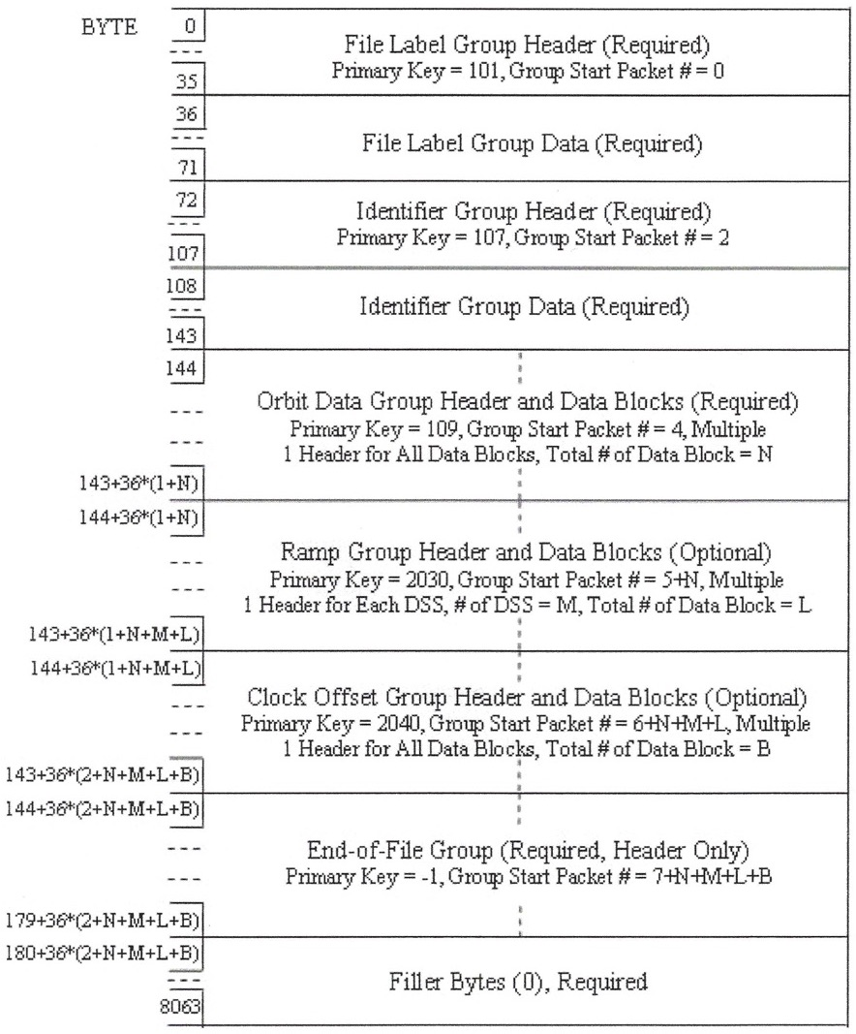
Figure 1. Physical structure of a hypothetical one block ODF (adapted from Figure 3-1 of [5]).
Example Data File:
An example ODF generated during the MESSENGER mission has been included in the Radio Science Documentation bundle. Data were collected at DSN ground stations 14, 43, and 63 over about 35 hours on June 4 and 5 in 2007; values were sampled every 60 s. The logical identifier of the example ODF is
urn:nasa:pds:radiosci_documentation:dsn_trk-2-18:odf07155
A hexadecimal dump of the first 16 records of the example file is shown in Figure 2.
0000000 00 00 00 65 00 00 00 00 00 00 00 01 00 00 00 00
0000020 00 00 00 00 00 00 00 00 00 00 00 00 00 00 00 00
0000040 00 00 00 00
54 44 44 53 20 20 20 20 41 4d 4d 4f
0000060 53 20 20 20 00 00 00 ec 00 10 58 02 00 03 86 01
0000100 01 29 8c 45 00 00 00 00
00 00 00 6b 00 00 00 00
0000120 00 00 00 01 00 00 00 02 00 00 00 00 00 00 00 00
0000140 00 00 00 00 00 00 00 00 00 00 00 00
54 49 4d 45
0000160 54 41 47 20 4f 42 53 52 56 42 4c 20 46 52 45 51
0000200 2c 41 4e 43 49 4c 4c 41 52 59 2d 44 41 54 41 20

0000220 00 00 00 6d 00 00 00 00 00 00 00 01 00 00 00 04
0000240 00 00 00 00 00 00 00 00 00 00 00 00 00 00 00 00
0000260 00 00 00 00
6c 02 80 48 00 00 00 00 ff fa 28 ee
0000300 d8 6f 2b 24 4f c0 05 c4 02 76 42 17 77 80 8d e8
0000320 00 00 00 05 dc 00 00 00
6c 02 80 84 00 00 00 00
0000340 ff fa 29 31 e2 78 95 ed 4f c0 05 c4 02 76 42 17
0000360 77 80 8d e8 00 00 00 05 dc 00 00 00
6c 02 80 c0
0000400 00 00 00 00 ff fa 29 72 f8 48 f8 6e 4f c0 05 c4
0000420 02 76 42 17 77 80 8d e8 00 00 00 05 dc 00 00 00

0000440 6c 02 80 fc 00 00 00 00 ff fa 29 b2 e8 f4 f5 8c
0000460 4f c0 05 c4 02 76 42 17 77 80 8d e8 00 00 00 05
0000500 dc 00 00 00
6c 02 81 38 00 00 00 00 ff fa 29 f1
0000520 cc 26 e0 c4 4f c0 05 c4 02 76 42 17 77 80 8d e8
0000540 00 00 00 05 dc 00 00 00
6c 02 81 74 00 00 00 00
0000560 ff fa 2a 2e e3 86 7a e2 4f c0 05 c4 02 76 42 17
0000600 77 80 8d e8 00 00 00 05 dc 00 00 00
6c 02 81 b0
0000620 00 00 00 00 ff fa 2a 6a fa bc 7a 66 4f c0 05 c4
0000640 02 76 42 17 77 80 8d e8 00 00 00 05 dc 00 00 00

0000660 6c 02 81 ec 00 00 00 00 ff fa 2a a6 e9 33 71 f2
0000700 4f c0 05 c4 02 76 42 17 77 80 8d e8 00 00 00 05
0000720 dc 00 00 00
6c 02 82 28 00 00 00 00 ff fa 2a e1
0000740 e5 67 73 2e 4f c0 05 c4 02 76 42 17 77 80 8d e8
0000760 00 00 00 05 dc 00 00 00
6c 02 82 64 00 00 00 00
0001000 ff fa 2b 1b fa 03 37 ba 4f c0 05 c4 02 76 42 17
0001020 77 80 8d e8 00 00 00 05 dc 00 00 00
6c 02 82 a0
0001040 00 00 00 00 ff fa 2b 55 ea 62 f4 53 4f c0 05 c4
0001060 02 76 42 17 77 80 8d e8 00 00 00 05 dc 00 00 00
Figure 2. Hexadecimal dump of the first 16 records of the example data file. Byte addresses (in octal) are in the left column. Line breaks have been inserted to mark record boundaries. The dump was created using the unix command od -t x1 odf07155.dat
The first six records may be unpacked as shown in Tables 1-3. Records 1-4 are unpacked following the specification in Tables 3-1, 3-2, 3-1, and 3-3 [5], respectively.
Table 1. Unpacking Records 1-4
Record | Bytes | Hex | Description | Unpacked Value
1 | 0-3 | 00 00 00 65 | Primary Key | 101
1 | 4-7 | 00 00 00 00 | Secondary Key | 0
1 | 8-11 | 00 00 00 01 | Logical Record Length | 1
1 | 12-15 | 00 00 00 00 | Group Start Packet Number | 0
1 | 16-19 | 00 00 00 00 | Not used | N/A
1 | 20-23 | 00 00 00 00 | Not used | N/A
1 | 24-27 | 00 00 00 00 | Not used | N/A
1 | 28-31 | 00 00 00 00 | Not used | N/A
1 | 32-35 | 00 00 00 00 | Not used | N/A
2 | 0-7 | 54 44 44 53 20 20 20 20 | System ID | ‘TDDS’ + 4 <SP>
2 | 8-15 | 41 4d 4d 4f 53 20 20 20 | Program ID | ‘AMMOS’ + 3 <SP>
2 | 16-19 | 00 00 00 ec | Spacecraft Number | 236
2 | 20-23 | 00 10 58 02 | File Creation Date (YYMMDD format*) | 1071106
2 | 24-27 | 00 03 86 01 | File Creation Time (HHMMDD format) | 230913
2 | 28-31 | 01 29 8c 45 | File Reference Date (YYYYMMDD) | 19500101
2 | 32-35 | 00 00 00 00 | File Reference Time (HHMMDD) | 000000
3 | 0-3 | 00 00 00 6b | Primary Key | 107
3 | 4-7 | 00 00 00 00 | Secondary Key | 0
3 | 8-11 | 00 00 00 01 | Logical Record Length | 1
3 | 12-15 | 00 00 00 02 | Group Start Packet Number | 2
3 | 16-19 | 00 00 00 00 | Not used | N/A
3 | 20-23 | 00 00 00 00 | Not used | N/A
3 | 24-27 | 00 00 00 00 | Not used | N/A
3 | 28-31 | 00 00 00 00 | Not used | N/A
3 | 32-35 | 00 00 00 00 | Not used | N/A
4 | 0-7 | 54 49 4d 45 54 41 47 20 | Identifier 1 | ‘TIMETAG’ + 1 <SP>
4 | 8-15 | 4f 42 53 52 56 42 4c 20 | Identifier 2 | ‘OBSRVBL’ + 1 <SP>
4 | 16-35 | 46 52 45 51 2c 41 4e 43 49 4c 4c 41 52 59 2d 44 41 54 41 20 | Identifier 3 | ‘FREQ,’ + ‘ANCIL’ + ‘LARY-‘ + ‘DATA’ + 1 <SP>
* Table 3-2 [5] states that File Creation Date will be in YYMMDD format and that values 50 ≤ YY ≤ 99 are with respect to 1900, while values 00 ≤ YY ≤ 49 are with respect to 2000. In fact, we have found that all File Creation Dates are with respect to 1900 and that YY for years starting in 2000 has values greater than or equal to 100. In this example YY = 107 for year 2007.
Record 5 is unpacked following the specification in Table 3-1 [5].
Table 2. Unpacking Record 5
Record | Bytes | Hex | Description | Unpacked Value
5 | 0-3 | 00 00 00 6d | Primary Key | 109
5 | 4-7 | 00 00 00 00 | Secondary Key | 0
5 | 8-11 | 00 00 00 01 | Logical Record Length | 1
5 | 12-15 | 00 00 00 04 | Group Start Packet Number | 4
5 | 16-19 | 00 00 00 00 | Not used | N/A
5 | 20-23 | 00 00 00 00 | Not used | N/A
5 | 24-27 | 00 00 00 00 | Not used | N/A
5 | 28-31 | 00 00 00 00 | Not used | N/A

Record 6 bits 1-160 is unpacked using the specification in Table 3-4a [5] while bits 161-288 are unpacked using the specification in Table 3-4d [5].
The Record Time Tag is reconstructed by summing integer values in bits 1-32 with the fractional component (to the right of the decimal point) in bits 33-42 to give 1812103240.0 seconds.
The Data Type of the observable in this record is 11 (one-way Doppler), as given by bits 148-153. The value of one-way Doppler is -382738.663803100 Hz from the combination of bits 65-96 and bits 97-128.
The Reference Frequency (bits 179-224) is 137097*2²⁴ + 8424936 = 2299812417000 mHz. The Compression Time (bits 245-266) is 60.00 s.
All of the unpacked values, including values from the Ramp Group and End of File Group, are given in associated file odf071255.txt. There is no Clock Offset Group in this ODF.
Two-way Doppler (Data Type 12) is plotted versus Record Time Tag in Figure 3.
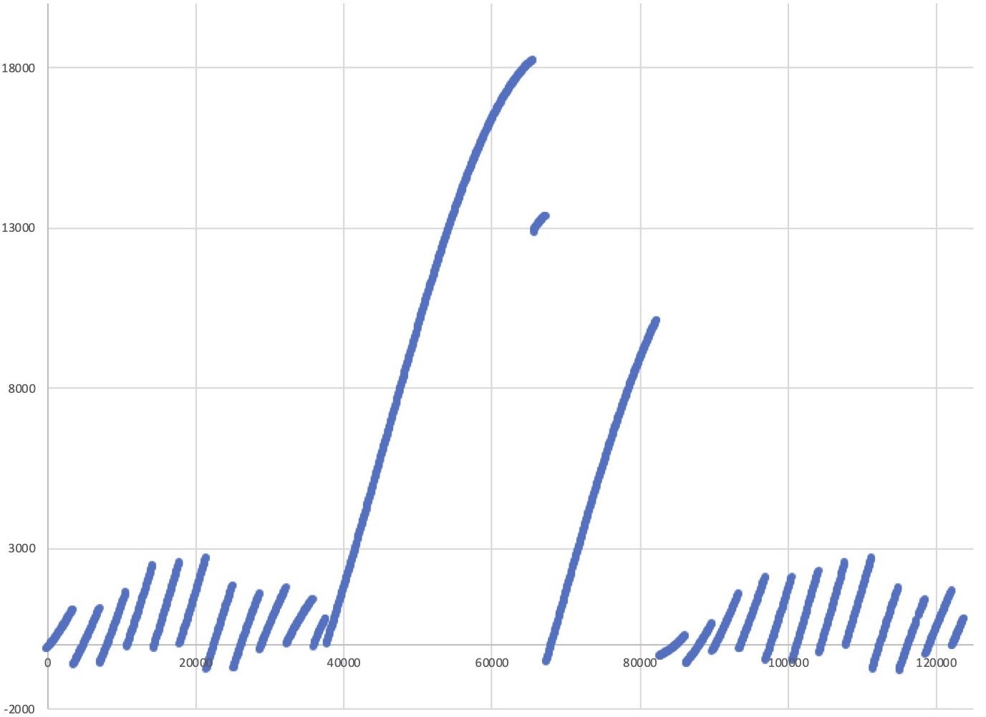
Figure 3. MESSENGER two-way Doppler (Hz) versus time (s) starting at 2009-155T10:23:17. The initial time and Doppler values have been treated as biases and have been subtracted to facilitate display.
Table 3. Unpacking Record 6
Record | Bytes or Bits | Hex or Binary | Description | Unpacked Value
6 | 1-32 | 6c 02 80 48 | Record Time Tag, seconds past reference date/time (integer part) | 1812103240
6 | 33-42 | 0000000000 | Record Time Tag, seconds past reference date/time (fractional part) | 0
6 | 43-64 | 0 00 00 | Primary Receiving Station Downlink Delay | 0
6 | 65-96 | ff fa 28 ee | Observable, integer part | -382738
6 | 97-128 | d8 6f 2b 24 | Observable, fractional part (x 10⁻⁹) | -663803100
6 | 129-131 | 010 | Format ID | 2
6 | 132-138 | 0111111 | Primary Receiving Station ID Number | 63
6 | 139-145 | 0000000 | Transmitting Station ID Number | 0
6 | 146-147 | 00 | Transmitting Station Network ID | 0 (DSN)
6 | 148-153 | 001011 | Data Type ID | 11 (one-way Doppler)
6 | 154-155 | 10 | Downlink Band ID | 2 (X-band)
6 | 156-157 | 00 | Uplink Band ID | 0 (N/A)
6 | 158-159 | 10 | Reference Frequency Band ID | 2 (X-band)
6 | 160 | 0 | Data Validity Indicator | 0 (valid)
6 | 161-167 | 0000001 | Receiver Channel N umber | 1
6 | 168-177 | 0011101100 | Spacecraft ID | 236 (MESSENGER)
6 | 178 | 1 | Receiver/Exciter Independent Flag | 1 (Rx/Tx independent)
6 | 179-200 | 02 17 77 | Reference Frequency (high part) (x 2²⁴ mHz) | 137079
6 | 201-224 | 80 8d e8 | Reference Frequency (low part) (mHz) | 8424936
6 | 225-244 | 00 00 00 | Reserved | N/A
6 | 245-266 | 00 17 70 | Compression Time (0.01 s) | 6000
6 | 267-288 | 00 00 00 | Transmitting Station Uplink Delay | 0

