Interpretation and Use of Binary ATDF/TDF Data
The Archival Tracking Data File (ATDF or TDF) was generated by the NASA Deep Space Network (DSN) and contained the most detailed results from radio tracking of spacecraft over three decades ending in the mid-2000s. ATDFs were written in very densely packed binary formats, which have been difficult for some users to parse.
This document describes and illustrates extraction of values from TDFs with emphasis on files created since the mid-1980s. These files were generated according to the TRK-2-25 interface specification, a module within the DSN 820-013 External Interface Specification. The TRK-2-25 format has evolved; but the general structure and content of the files have remained relatively stable#. When production of TDFs was discontinued in the mid-2000s; users were encouraged to switch to the TRK-2-34 product, which was based on higher precision phase measurements.
This document does not address how one might use data found in a TDF file. Readers interested in use are referred to Morabito and Asmar (1995) and to Moyer (2000), which are cited in the PDS4 label for this document.
The following versions of the TRK-2-25 document were included in the Planetary Data System (PDS) Radio Science Documentation (RSD) bundle as of mid-2020. Other versions may be added as they become available.
[1] Document 820-013 (Rev. A), DSN System Requirements, Detailed Interface Design,
TRK-2-25, DSN Tracking System Interfaces, Archival Tracking Data File Interface, initial release data 1986-01-01.
[2] Document 820-013 (Rev. A), DSN System Requirements, Detailed Interface Design,
TRK-2-25, DSN Tracking System Interfaces, Archival Tracking Data File Interface, reissued 1988-10-15.
[3] MGSO System Requirements, Detailed Interface Design, SFOC-NAV-TRK-2-25, MGSO Tracking System Interfaces, Archival Tracking Data File Interface, reissued 1996-07-31.
File and Record Formats:
Each TDF comprises one or more blocks of 8064 bytes, divided into 288-byte (2304-bit) records. When the volume of data records is not an integer multiple of 8064 bytes, zero-filled records are used to pad the final block to 8064 bytes.
There may be up to three record types — usually a File Identification Record, followed by a Transponder record, and then one or more Tracking Data Records in chronological order. Tracking Data Records may contain either high- or low-rate data, but both have the same record format. If/when data from two or more DSN passes are concatenated into a single file, there may be additional File Identification and/or Transponder Records marking the beginning of data from the new source.
The TDF was originally created on Univac computers which had six 6-bit bytes per word; a double precision number occupied two words or 72 bits. Data were written to tape with most-significant byte first (MSB order). With the industry transition to 8-bit bytes, specifications were revised; but the bits remained largely unchanged so that files could be read on both 32-bit and 36-bit machines. The industry transition from MSB to least significant byte first (LSB order) has complicated extraction of values from the binary data on some platforms since TDF data have always been written in MSB order. Displaying data in byte order should provide the same view whether the user’s platform is MSB or LSB.
Normally, the File Identification Logical Record is the first record in an ATDF/TDF; it gives the creation date, time, and source of the file. Its contents are specified in Table 0 below, adapted from [1-3]. The structures of the ATDF Transponder Logical Record and ATDF Tracking Data Logical Record are documented in Tables 3-2 and 3-3 of [1-3]. Packed format ‘imn’ denotes an unsigned integer with mn bits where bits are continuous across byte boundaries (as viewed in byte, or MSB, order). Packed format ‘smn’ denotes signed integers in two’s-complement storage.
Table 0. ATDF File Identification Logical Record
Item Number | Packed Format | Description
1 | i32 | Record format (set to ‘0’)
2 | i8 | Reserved (set to ‘128’)
3 | i32 | Record type (set to ‘10’)
4 | i12 | File creation year modulo 1900
5 | i16 | File creation day-of-year
6 | i8 | File creation hour
7 | Ii2 | File creation minute
8 | i8 | File creation second
9 | i12 | Reserved (set to ‘0’)
10 | i16 | Spacecraft ID number
11 | I8 | First character of source
12 | I8 | Second character of source
13 | I8 | Third character of source
14 | I12 | Fourth character of source
15 | I16 | Fifth character of source
16 | I8 | Sixth character of source
17 | I12 | Seventh character of source
18 | I8 | Eighth character of source
19 | I16 | Not used (set to ‘0’)
20 | I4 | Not used (set to ‘0’)
21-84 | 64*i32 | Not used (set to ‘0’

The eight characters identifying the source (items 11-18 in Table 0) vary depending on the era during which the file was written; in 1986 [1], they were ASCII ‘IDR ATDF’, in 1988 [2], they were either ‘IDR ATDF’ or ‘SPR ATDF’, and in 1996 [3] and 1998 they were ‘R/T ATDF’. There may be other values, especially in years before 1986.
The uneven parsing (for example, 16 bits for some characters and 8 or 12 bits for others) is an artifact of the original Univac structure.

Example Data File:
An example TDF generated during the Cassini mission has been included in the Radio Science Documentation bundle. Data were collected at DSN ground station 25 over about 10.3 hours on 26 November 2001. To save space, only the first 504 and the last 56 records of the original TDF are included in the example. The logical identifier (LID) for the example file is
urn:nasa:pds:radiosci_documentation:dsn_trk-2-25:tdf01330
A hexadecimal dump of the first 4 records of the example file is shown in Figure 1 below
Record 1:
0000000 00 00 00 00 80 00 00 00 0a 06 60 05 01 20 26 0a
0000016 00 00 05 25 22 f5 40 20 00 41 54 04 44 60 00 00
0000032 00 00 00 00 00 00 00 00 00 00 00 00 00 00 00 00
...
Record 2:
0000288 00 00 00 00 80 00 00 00 1e 06 50 14 a0 50 04 26
0000304 00 00 05 20 00 00 00 65 01 4a 0f 01 42 10 00 00
0000320 00 03 81 c9 00 03 10 ab 00 00 00 00 00 00 00 00
0000336 00 00 00 00 00 00 00 00 00 00 00 00 00 00 00 00
...
Record 3:
0000576 00 00 00 08 00 00 00 00 5a 06 50 14 a0 50 42 60
0000592 00 00 06 40 06 00 00 52 00 00 00 00 00 00 00 40
0000608 00 00 00 00 00 00 00 00 00 00 00 00 00 00 00 00
...
0000752 00 00 00 00 03 00 00 00 00 00 00 00 00 00 00 00
0000768 00 00 00 00 00 00 00 00 00 00 00 00 00 00 00 00
...
0000800 00 04 00 00 00 00 00 00 00 00 00 20 b9 ff 20 35
0000816 49 5b 80 00 20 00 00 00 00 00 00 00 00 00 00 00
0000832 00 00 00 00 00 00 00 00 00 00 00 00 00 00 00 00
...
Record 4:
0000864 00 00 00 08 00 00 00 00 5b 06 50 14 a0 50 42 70
0000880 00 00 06 40 81 22 00 52 00 00 00 00 7d 0c 14 40
0000896 00 00 00 64 00 00 10 43 1c 76 16 81 b8 00 00 00
0000912 00 00 00 00 00 00 00 00 00 00 00 00 00 00 00 00
0000928 00 00 00 00 00 00 00 00 00 00 02 04 de 72 e4 0d
0000944 20 00 00 00 00 00 00 01 04 34 39 a2 b1 35 80 00
0000960 01 04 36 ab e3 fe 37 80 00 01 04 39 1e 25 4a fb
0000976 00 00 01 04 3b 90 66 9a 6e 00 00 01 04 3e 02 a7
0000992 ea 1f 80 00 01 04 40 74 e9 3c fd 80 00 01 04 42
0001008 e7 31 06 73 80 00 01 04 45 59 72 5e ef 00 00 01
0001024 04 47 cb b3 b6 af 0f ff ff c1 51 00 00 00 00 00
0001040 03 c0 00 dd 03 00 00 00 00 00 9f fa 3d 01 2c c8
0001056 01 2c c8 00 00 00 00 00 00 00 00 00 00 00 00 00
0001072 00 00 00 00 00 00 00 00 00 00 00 00 00 00 00 00
0001088 00 00 00 00 00 00 ff f6 c7 c0 00 00 00 00 00 00
0001104 00 00 00 00 00 00 00 00 00 00 00 00 00 00 00 00
0001120 00 00 00 00 00 00 00 00 00 00 00 00 00 00 00 00
0001136 00 00 00 00 00 00 00 00 00 00 00 00 00 00 00 00
Figure 1. Hexadecimal dump of the first 4 records of the example data file. Byte addresses (in decimal) are in the left column. The dump was created using the unix command od -t x1 tdf01330.dat +0.
A complete ASCII listing of the non-zero contents of the example file is included in accompanying file tdf01330.csv. Each record contains 1180 bytes, including an ASCII <CR><LF> record delimiter in bytes 1179 and 1180. Fields within each record are separated by commas. To pad the file to an integer multiple of 8064 bytes, there are nine ‘empty’ records at the end of tdf01330.dat; they are not included in tdf01330.csv.
The first record has fields corresponding to items 1-18 in Table 1 below. An extra field has been added in tdf01330.csv after field 18; it contains the character string formed from the contents of items 11-18. The remainder of the first tdf01330.csv record is filled with ASCII blanks except for the <CR><LF> delimiter in bytes 1179 and 1180.
The second record has fields corresponding to items 1-23 in Table 2 below. An extra field has been added in tdf01330.csv after field 23; it contains the reconstructed value from items 21 and 23 using scientific notation (1p1d22.15). The remainder of the record is filled with ASCII blanks except for the <CR><LF> delimiter in bytes 1179 and 1180.
Records 3-551 have fields corresponding to items 1-141 in Tables 3 and 4 below. Extra fields have been added after items 32, 35, 44, 48, 51, 54, 57, 60, 63, 66, 69, 72, 121, 125, and 141 to contain reconstructed values of preceding H/P, I/P, and/or L/P items using scientific notation (1p1d22.15). The <CR><LF> record delimiter is in bytes 1179 and 1180.
Table 1 – Extraction of Values from Record 1
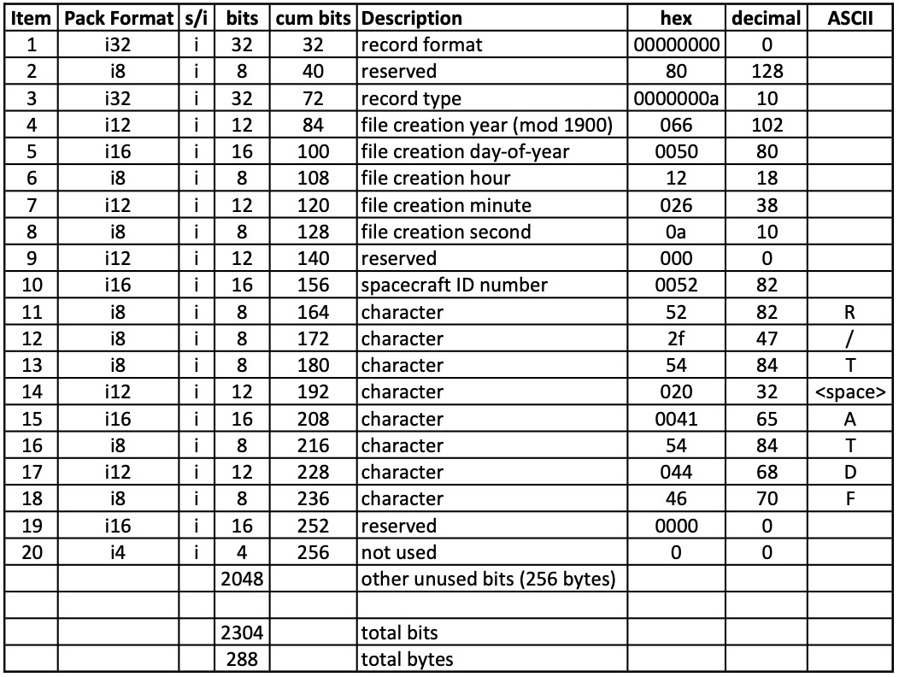
Table 2 – Extraction of Values from Record 2
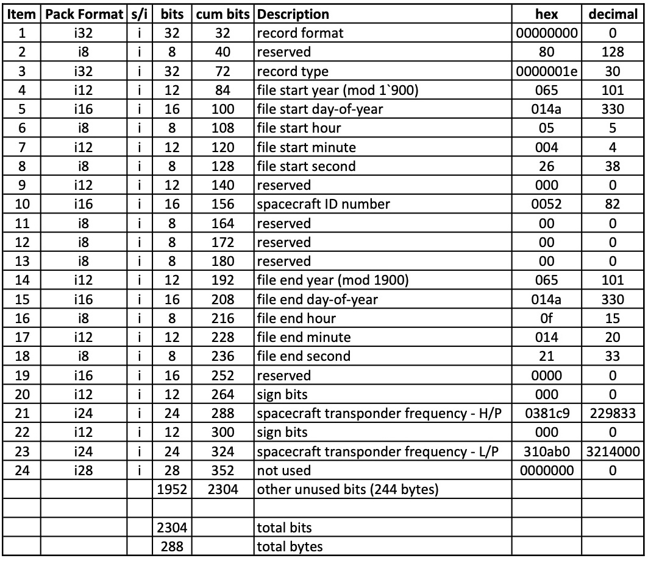
The spacecraft transponder frequency (items 20-23) may be reconstructed using the expression following Table 3-2 in [3]:
spacecraft_transponder_frequency = (H/P)*10⁴ + (L/P) * 10⁻³ = 2298333214.0 Hz

Table 3a – Extraction of Values from Record 3 (items 1-55)
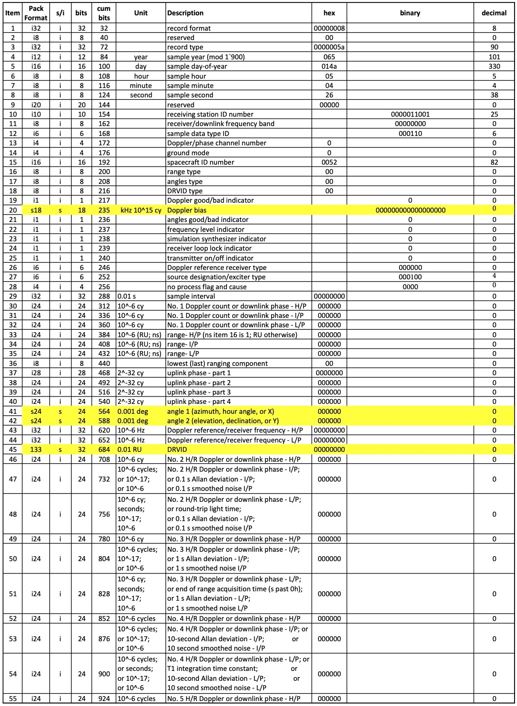
Table 3b – Extraction of Values from Record 3 (items 56-100)
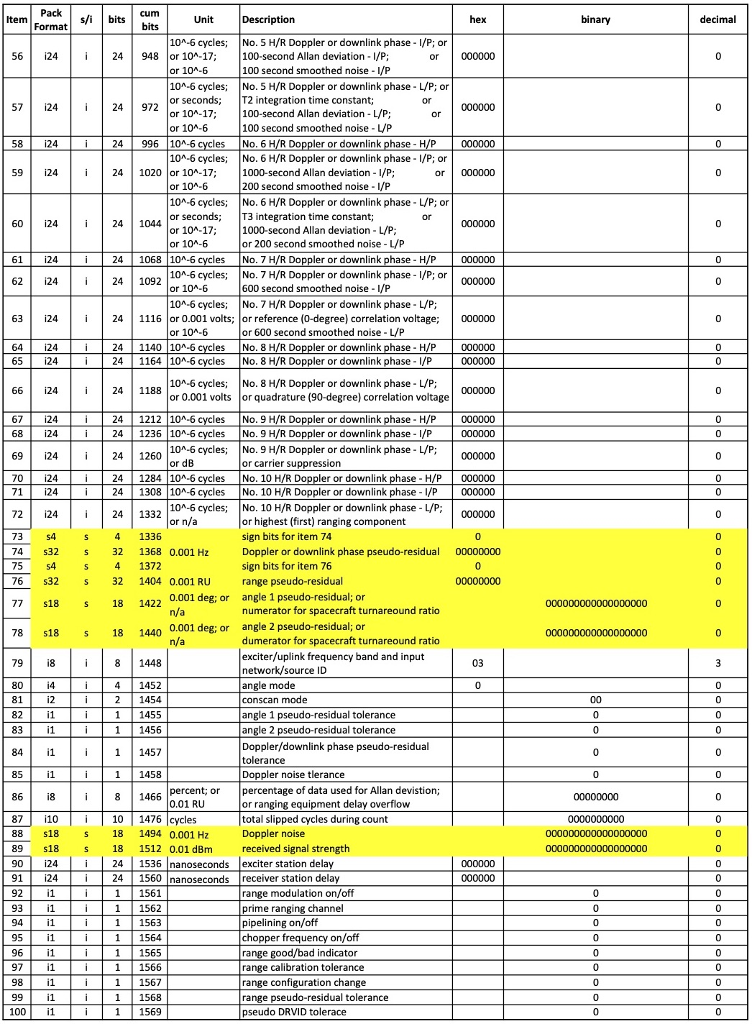
Table 3c – Extraction of Values from Record 3 (items 101-141)
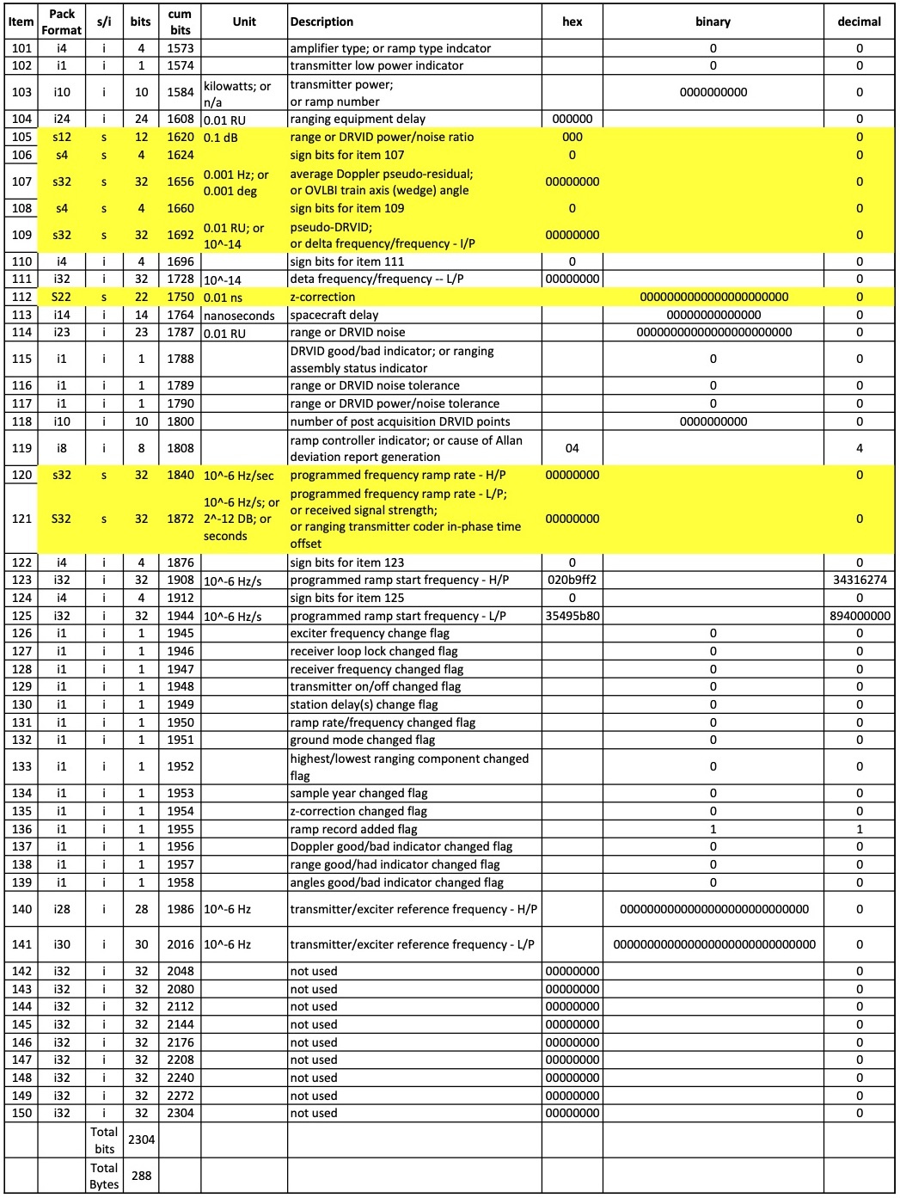
A. Negative Values: Although there are signed integers in record 3 (yellow highlighting), none has a negative value.
B. High Precision Values: There are H/P (high part), I/P (intermediate part), and/or L/P (low part) integers at items 30-32, 33-35, 43-44, 46-48, 49-51, 52-54, 55-57, 58-60, 61-63, 64-66, 67-69, 70-72, 120-121, 122-125, and 140-141. However, only the value at items 122-125 is non-zero. It may be reconstructed using the expression for ramp frequency at the end of Table 3-3 in [3]:
programmed_ramp_start_frequency = (H/P) * 10³ + (L/P) * 10⁻⁶ = 34316274894.0
Note that reconstruction following the expression in [3] does not give the scaling required by the ‘unit’ column in the same table (see Appendix B, paragraph (3) of this document).

Table 4a – Extraction of Values from Record 4 (items 1-54)
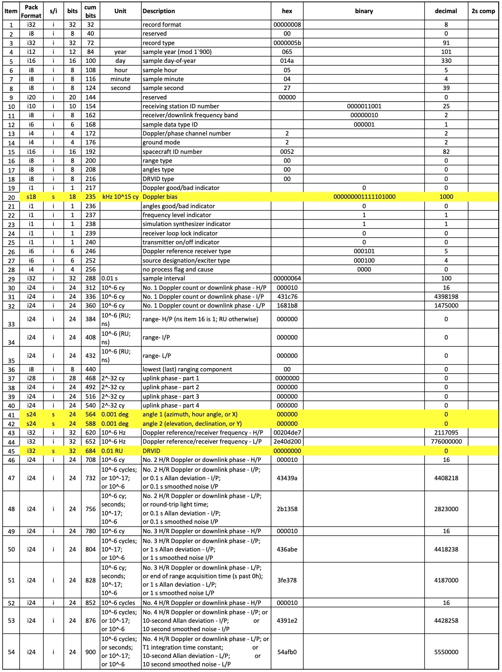
Table 4b – Extraction of Values from Record 4 (items 55-102)
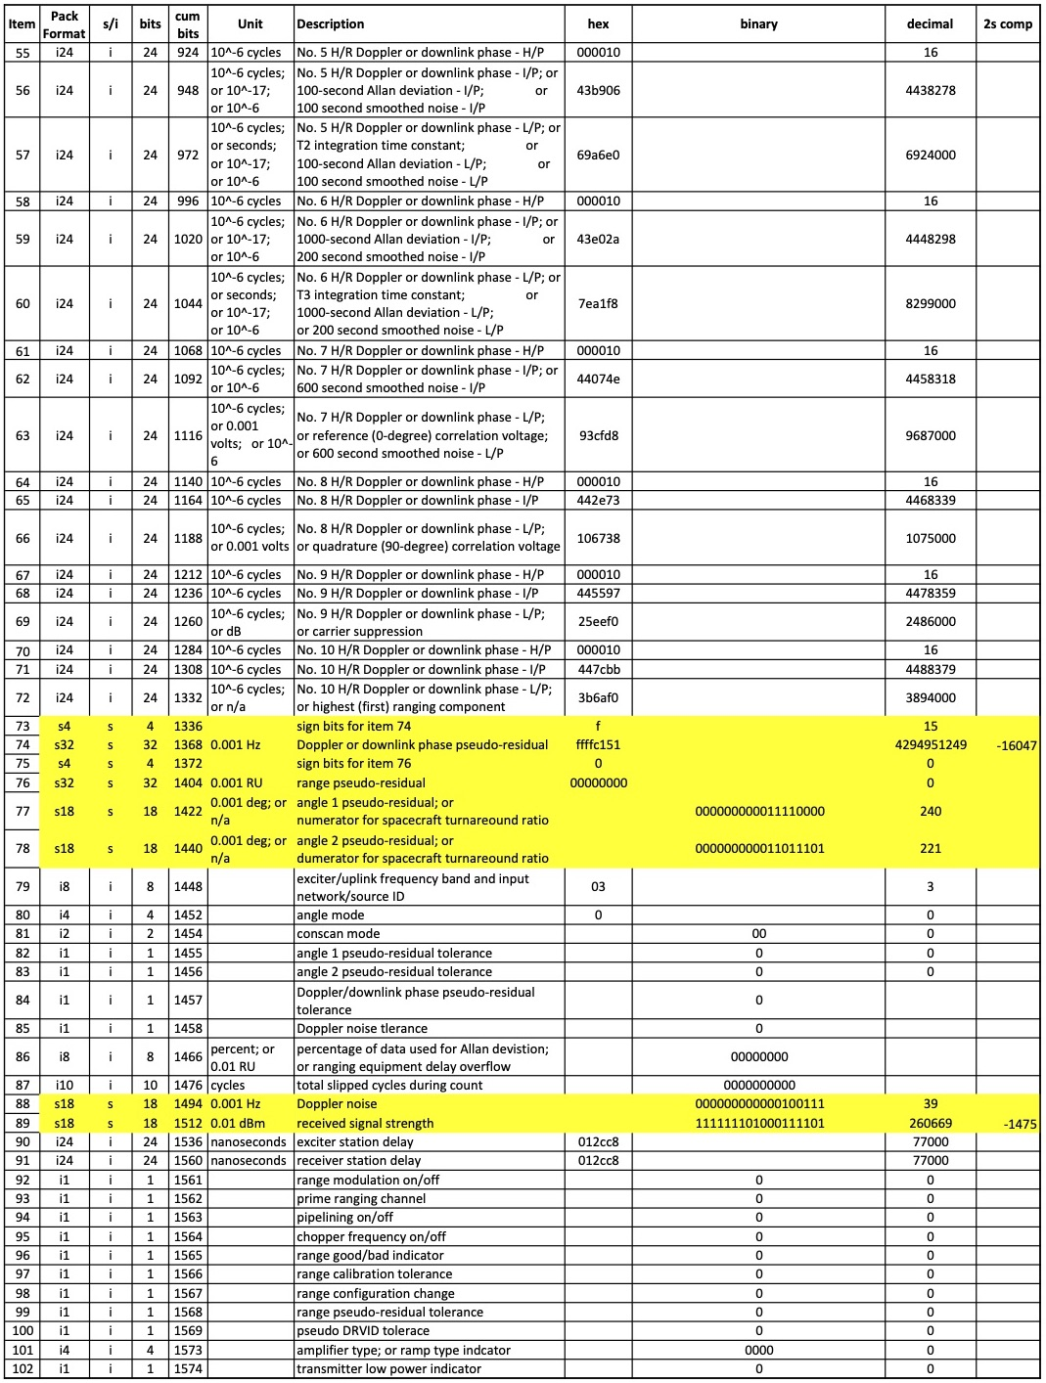
Table 4c – Extraction of Values from Record 4 (items 103-141)
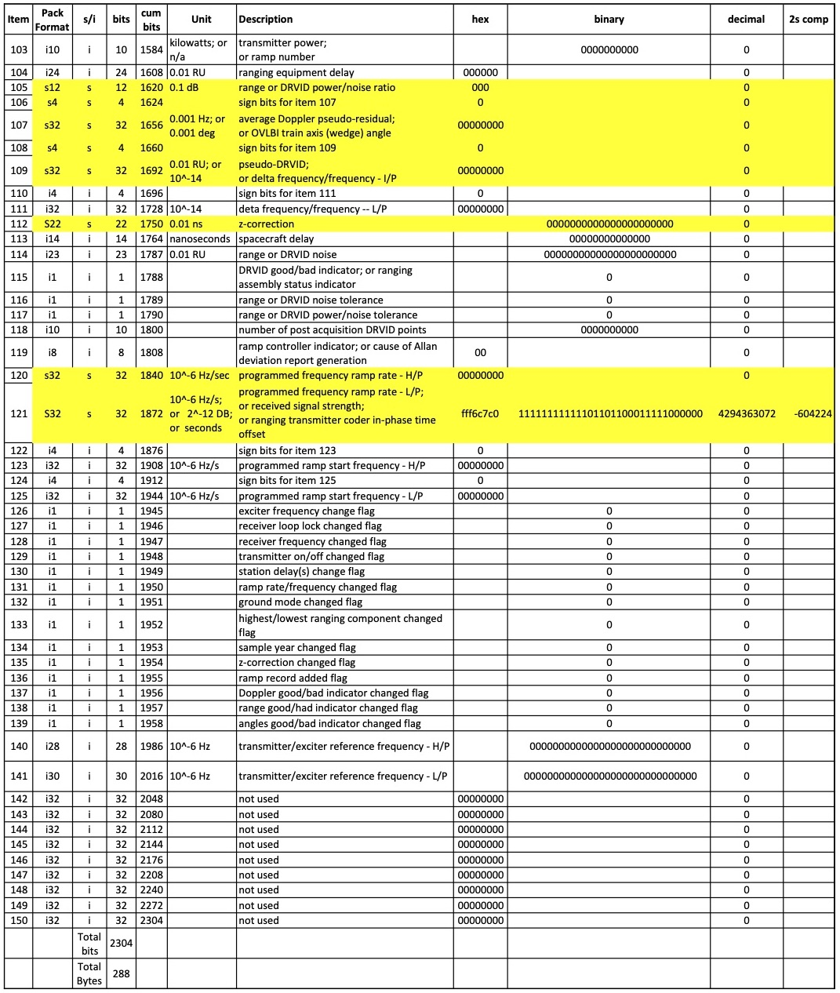
A. Negative Values: There are 21 signed integers in record 4; they are shown in Table 4 with yellow highlighting. Only three have negative values.
(1) Item 74 is a 32-bit signed integer; interpreted as two’s complement, its value is:
Doppler_pseudo-residual = -16047 mHz
since sample data type (item 12) has value ‘1’ (high-rate Doppler).
(2) Item 89 is an 18-bit signed integer; after sign extension to 32 bits, two’s complement interpretation, and assignment of “unit = 0.01 dBm” (from Table 3-3, row 89, column 3 in [3]), its value is:
received_signal_strength = -14.75 dBm
However, this value appears to be in error by a factor of 10 (see Appendix B, paragraph (2) of this document).
(3) Item 121 is a 32-bit signed integer; interpreted as two’s complement, its value is:
programmed_frequency_ramp_rate = -0.604224 Hz/s
B. High Precision Decimal Values: There are H/P (high part), I/P (intermediate part), and/or L/P (low part) integers at items 30-32, 33-35, 43-44, 46-48, 49-51, 52-54, 55-57, 58-60, 61-63, 64-66, 67-69, 70-72, 120-121, 122-125, and 140-141. All are components of high precision quantities requiring more than 32 bits; most have non-zero values. The full values can be constructed by concatenating the digits as shown in Table 5 below. Application of ‘unit’ from column 3 in Table 3-3 of [3] provides the necessary scaling. Use of the expression following Table 3-3 [3] provides the wrong scaling (see Appendix B, paragraph (3)). An example of data plotted from the example file is shown in Figure 2.
Table 5. Construction of Numerical Values from H/P, I/P, and L/P Components
Items | Description | H/P | I/P | L/P | Value
30-32 | No.1 Doppler count | 16 | 4398198 | 1475000 | 1643981981.475
33-35 | Range | 0 | 0 | 0 | 0.0
43-44 | Doppler reference frequency | 217095 |  | 776000000 | 217095776.000
46-48 | No. 2 Doppler count | 16 | 4408218 | 2823000 | 1644082182.823
49-51 | No. 3 Doppler count | 16 | 4418238 | 4187000 | 1644182384.187
52-54 | No. 4 Doppler count | 16 | 4428258 | 5550000 | 1644282585.550
55-57 | No. 5 Doppler count | 16 | 4438278 | 6924000 | 1644382786.924
58-60 | No. 6 Doppler count | 16 | 4448298 | 8299000 | 1644482988.299
61-63 | No. 7 Doppler count | 16 | 4458318 | 9687000 | 1644583189.687
64-66 | No. 8 Doppler count | 16 | 4468339 | 1075000 | 1644683391.075
67-69 | No. 9 Doppler count | 16 | 4478359 | 2486000 | 1644783592.486
70-72 | No. 10 Doppler count | 16 | 4488379 | 3894000 | 1644883793.894
120-121 | Programmed ramp rate | 0 |  | -604224 | -0.604224
122-125 | Programmed ramp start frequency | 0 |  | 0 | 0.0
140-141 | Transmit reference frequency | 0 |  | 0 | 0.0

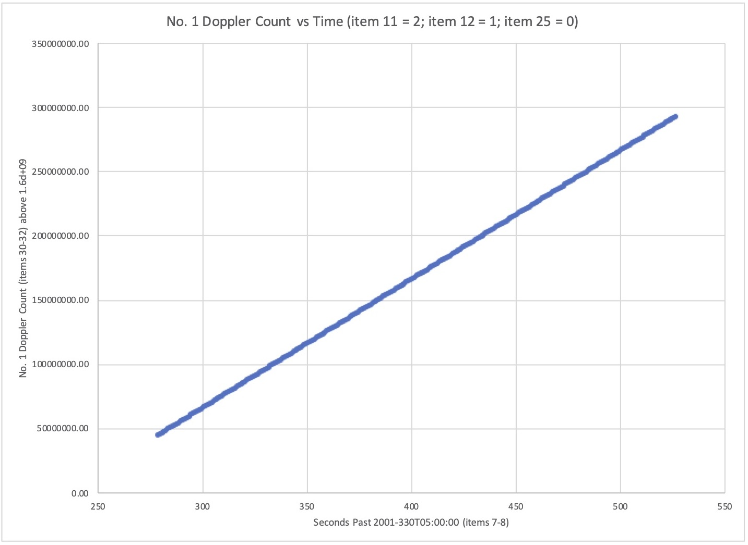
Figure 2. X-band No. 1 Doppler count from the example file plotted versus time from the example file.

C. High Precision Binary Values: The uplink_phase value is given in 4 parts (items 37-40), each having 24 bits. Whereas the “Value” in Table 5 is obtained by applying various powers of 10 to the H/P, I/P, and L/P components, the quadruple precision equation after Table 3-3 in [3] yields the final result using powers of 2 — the same result as concatenating the bits from the components into a 96-bit integer and interpreting the result in units of 2⁻³² cycles.
Other Sample Data Types:
Most records in the example data file tdf01330.dat contain high-rate Doppler measurements (item 12 = 1). Record 3 contains ramp data (item 12 = 6); that record is parsed in Table 3. There are two other sample data types in the example file.
Record 325 contains range data (item 12 = 5); the complete record contents are expanded below:
Input file tdf01330.dat: record 325
Item 001: Record format = 8
Item 002: reserved0 = 0
Item 003: Record type = 90
Item 004: Sample year, modulo 1900 = 101
Item 005: Sample day-of-year = 330
Item 006: Sample hour = 5
Item 007: Sample minute = 7
Item 008: Sample second = 18
Item 009: reserved31 (set to 0) = 0
Item 010: Receiving station ID number = 25
Item 011: Receiver/downlink frequency band = 2
Item 012: Sample data type ID = 5
Item 013: Doppler/phase channel number = 0
Item 014: Ground mode = 6
Item 015: Spacecraft ID number = 82
Item 016: Range type = 7
Item 017: Angles type = 0
Item 018: DRVID type = 0
Item 019: Doppler good/bad indicator = 0
Item 020: Doppler bias or overflow from Items 30-32 and 46-72 = 1000
Item 021: Angles good/bad indicator = 0
Item 022: Frequency level indicator = 1
Item 023: Simulation synthesizer indicator = 0
Item 024: Receiver loop lock indicator = 0
Item 025: Transmitter on/off indicator = 0
Item 026: Doppler reference receiver type = 5
Item 027: Source designation/exciter type = 4
Item 028: No process flag and cause = 0
Item 029: Sample interval (0.01 seconds) = 0
Item 030: No. 1 Doppler count or downlink phase - H/P = 18
Item 031: No. 1 Doppler count or downlink phase - I/P = 331138
Item 032: No. 1 Doppler count or downlink phase - L/P = 2755000
Items 030-032: Double precision reconstruction = 1.803311382755000D+09
Item 033: Range - H/P = 0
Item 034: Range - I/P = 2970017
Item 035: Range - L/P = 6000000
Items 033-035: Double precision reconstruction (range units) = 2.970017600000000D+07
Item 036: Lowest (last) ranging component = 19
Item 037: Uplink phase - part 1 = 0
Item 038: Uplink phase - part 2 = 0
Item 039: Uplink phase - part 3 = 0
Item 040: Uplink phase - part 4 = 0
Items 037-040: Double precision reconstruction (truncated from real*8) = 0.000000000000000D+00
Item 041: Angle 1 = 0
Item 042: Angle 2 = 0
Item 043: Doppler reference/receiver frequency - H/P = 7205592
Item 044: Doppler reference/receiver frequency - L/P = 128000000
Items 043-044: Double precision reconstruction = 7.205592128000000D+09
Item 045: DRVID = 0
Item 046: No. 2 Doppler or downlink phase - H/P = 0
Item 047: No. 2 Doppler, D/L phase, 0.1-s Allan dev, or 0.1-s smoothed noise - I/P = 0
Item 048: No. 2 Doppler, D/L phase, 0.1-s Allan Dev, or 0.1-s smoothed noise - L/P = 5718
Items 046-048: Double precision reconstruction = 5.718000000000000D-03
Item 049: No. 3 Doppler or downlink phase - H/P = 0
Item 050: No. 3 Doppler, D/L phase, 1.0-s Allan Dev, or 1.0-s smoothed noise - I/P = 0
Item 051: No. 3 Doppler, D/L phase, EoRAT, 1.0-s Allan Dev, 1.0-s smoothed noise - L/P = 18737
Items 049-051: Double precision reconstruction = 1.873700000000000D-02
Item 052: No. 4 Doppler or downlink phase - H/P = 0
Item 053: No. 4 Doppler, D/L phase, 10-s Allan Dev, or 10-s smoothed noise - I/P = 0
Item 054: No. 4 Dop, D/L phase, T1 integ, 10-s Allan Dev, or 10-s smoothed noise - L/P = 57
Items 052-054: Double precision reconstruction = 5.700000000000000D-05
Item 055: No. 5 Doppler or downlink phase - H/P = 0
Item 056: No. 5 Doppler, downlink phase, 100-s Allan Dev, or 100-s smoothed noise- I/P = 0
Item 057: No. 5 Dopp, D/L phase, T2 integ, 100-s Allan Dev, or 100-smoothed noise-L/P = 15
Items 055-057: Double precision reconstruction = 1.500000000000000D-05
Item 058: No. 6 Doppler or downlink phase - H/P = 0
Item 059: No. 6 Doppler, downlink phase, 1000-s Allan Dev, or 200-s smoothed noise-I/P = 0
Item 060: No. 6 Dopp, D/L phase, T3 integ, 1000-s AD, or 200-s smoothed noise - L/P = 0
Items 058-060: Double precision reconstruction = 0.000000000000000D+00
Item 061: No. 7 Doppler or downlink phase - H/P = 0
Item 062: No. 7 Doppler, downlink phase, or 600-s smoothed noise - I/P = 0
Item 063: No. 7 Dopp, D/L phase, ref (0-deg) corr voltage, or 600-s smoothed noise-L/P = 0
Items 061-063: Double precision reconstruction = 0.000000000000000D+00
Item 064: No. 8 Doppler or downlink phase - H/P = 0
Item 065: No. 8 Doppler or downlink phase - I/P = 0
Item 066: No. 8 Doppler, downlink phase, or quadrature (90-deg) corr voltage - L/P = 0
Items 064-066: Double precision reconstruction = 0.000000000000000D+00
Item 067: No. 9 Doppler or downlink phase - H/P = 0
Item 068: No. 9 Doppler or downlink phase - I/P = 0
Item 069: No. 9 Doppler, downlink phase, or carrier suppression - L/P = 3
Items 067-069: Double precision reconstruction = 3.000000000000000D-06
Item 070: No. 10 Doppler or downlink phase - H/P = 0
Item 071: No. 10 Doppler or downlink phase - I/P = 0
Item 072: No. 10 Doppler, downlink phase or highest (first) ranging component - L/P = 4
Items 070-072: Double precision reconstruction = 4.000000000000000D-06
Item 073: Sign bits for item 074 = 0
Item 074: Doppler or D/L phase residual = 0
Item 075: Sign bits for item 076 = 0
Item 076: Range pseudo-residual (0.001 range units) = 2097151
Item 077: Angle 1 pseudo-residual or numerator for spacecraft turnaround ratio = 880
Item 078: Angle 2 pseudo-residual or denominator for spacecraft turnaround ratio = 749
Item 079: Exciter/uplink frequency band and input network/source ID = 3
Item 080: Angle mode = 0
Item 081: Conscan mode = 0
Item 082: Angle 1 pseudo-residual tolerance = 0
Item 083: Angle 2 pseudo-residual tolerance = 0
Item 084: Doppler downlink phase pseudo-residual tolerance = 0
Item 085: Doppler noise tolerance = 0
Item 086: Percent data used for Allan Deviation, or Item 104 overflow = 0
Item 087: Total slipped cycles during count = 0
Item 088: Doppler noise = 0
Item 089: Received signal strength = 0
Item 090: Exciter station delay = 77000
Item 091: Receiver station delay = 77000
Item 092: Range modulation on/off = 1
Item 093: Prime ranging channel = 0
Item 094: Pipelining on/off = 0
Item 095: Chopper frequency on/off = 0
Item 096: Range good/bad indicator = 0
Item 097: Range calibration tolerance = 0
Item 098: Range configuration change = 0
Item 099: Range pseudo-residual tolerance = 0
Item 100: Pseudo-DRVID tolerance = 0
Item 101: Amplifier type or ramp number = 0
Item 102: Transmitter low power indicator = 0
Item 103: Transmitter power or ramp number = 3
Item 104: Ranging equipment delay (0.01 range units) = 1160350
Item 105: Range or DRVID power/noise ratio (0.1 dB) = 161
Item 106: Sign bits for item 107 = 15
Item 107: Average Doppler pseudo-residual or OVLBI train axis (wedge) angle = -16043
Item 108: Sign bits for item 109 = 0
Item 109: Pseudo DRVID or delta-frequency/frequency - I/P = 131
Item 110: Sign bits for item 111 = 0
Item 111: Delta-frequency/frequency - L/P = 0
Item 112: Z-correction = -27029
Item 113: Spacecraft delay = 420
Item 114: Range or DRVID noise (0.01 range units) = 6150
Item 115: DRVID good/bad or range assembly status = 0
Item 116: Range or DRVID noise tolerance = 0
Item 117: Range or DRVID power/noise tolerance = 0
Item 118: Number of post acquisition DRVID points = 0
Item 119: Ramp controller indicator = 0
Item 120: Programmed frequency ramp rate - H/P = 0
Item 121: Ramp rate (L/P), rcvd sig strength, or ranging tx coder in-phase time offset = 7220
Items 120-121: Double precision reconstruction = 7.220000000000000D-03
Item 122: Sign bits for item 123 = 0
Item 123: Programmed ramp start frequency - H/P = 0
Item 124: Sign bits for item 125 = 0
Item 125: Programmed ramp start frequency - L/P = 0
Items 122-125: Programmed ramp start frequency = 0.000000000000000D+00
Item 126: Exciter frequency changed flag = 0
Item 127: Receiver loop lock changed flag = 0
Item 128: Receiver frequency changed flag = 0
Item 129: Transmitter on/off changed flag = 0
Item 130: Station delay(s) changed flag = 0
Item 131: Ramp rate/frequency changed flag = 0
Item 132: Ground mode changed flag = 0
Item 133: Hi/lo ranging component changed flag = 0
Item 134: Sample year changed flag = 0
Item 135: Z-correction changed flag = 0
Item 136: Ramp record added flag = 0
Item 137: Doppler good/bad indicator change flag = 0
Item 138: Range good/bad indicator changed flag = 0
Item 139: Angles good/bad indicator changed flag = 0
Item 140: Transmitter/exciter reference frequency - H/P = 0
Item 141: Transmitter/exciter reference frequency - L/P = 0
Items 140-141: Double precision reconstruction = 0.000000000000000D+00
Record 512 contains Allan Deviation or Smoothed Noise data (item 12 = 8); the complete record contents are expanded below:
Input file tdf01330.dat: record 512
Item 001: Record format = 8
Item 002: reserved0 = 0
Item 003: Record type = 90
Item 004: Sample year, modulo 1900 = 101
Item 005: Sample day-of-year = 330
Item 006: Sample hour = 15
Item 007: Sample minute = 20
Item 008: Sample second = 20
Item 009: reserved31 (set to 0) = 0
Item 010: Receiving station ID number = 45
Item 011: Receiver/downlink frequency band = 2
Item 012: Sample data type ID = 8
Item 013: Doppler/phase channel number = 0
Item 014: Ground mode = 7
Item 015: Spacecraft ID number = 82
Item 016: Range type = 0
Item 017: Angles type = 0
Item 018: DRVID type = 0
Item 019: Doppler good/bad indicator = 0
Item 020: Doppler bias or overflow from Items 30-32 and 46-72 = 0
Item 021: Angles good/bad indicator = 0
Item 022: Frequency level indicator = 0
Item 023: Simulation synthesizer indicator = 0
Item 024: Receiver loop lock indicator = 0
Item 025: Transmitter on/off indicator = 0
Item 026: Doppler reference receiver type = 2
Item 027: Source designation/exciter type = 4
Item 028: No process flag and cause = 0
Item 029: Sample interval (0.01 seconds) = 323900
Item 030: No. 1 Doppler count or downlink phase - H/P = 0
Item 031: No. 1 Doppler count or downlink phase - I/P = 0
Item 032: No. 1 Doppler count or downlink phase - L/P = 0
Items 030-032: Double precision reconstruction = 0.000000000000000D+00
Item 033: Range - H/P = 0
Item 034: Range - I/P = 0
Item 035: Range - L/P = 0
Items 033-035: Double precision reconstruction = 0.000000000000000D+00
Item 036: Lowest (last) ranging component = 0
Item 037: Uplink phase - part 1 = 0
Item 038: Uplink phase - part 2 = 0
Item 039: Uplink phase - part 3 = 0
Item 040: Uplink phase - part 4 = 0
Items 037-040: Double precision reconstruction (truncated from real*8) = 0.000000000000000D+00
Item 041: Angle 1 = 0
Item 042: Angle 2 = 0
Item 043: Doppler reference/receiver frequency - H/P = 0
Item 044: Doppler reference/receiver frequency - L/P = 0
Items 043-044: Double precision reconstruction = 0.000000000000000D+00
Item 045: DRVID = 0
Item 046: No. 2 Doppler or downlink phase - H/P = 0
Item 047: No. 2 Doppler, D/L phase, 0.1-s Allan dev, or 0.1-s smoothed noise - I/P = 0
Item 048: No. 2 Doppler, D/L phase, 0.1-s Allan Dev, or 0.1-s smoothed noise - L/P = 40813
Items 046-048: Double precision reconstruction = 4.081300000000000D-02
Item 049: No. 3 Doppler or downlink phase - H/P = 0
Item 050: No. 3 Doppler, D/L phase, 1.0-s Allan Dev, or 1.0-s smoothed noise - I/P = 0
Item 051: No. 3 Doppler, D/L phase, EoRAT, 1.0-s Allan Dev, 1.0-s smoothed noise - L/P = 9476
Items 049-051: Double precision reconstruction = 9.476000000000000D-03
Item 052: No. 4 Doppler or downlink phase - H/P = 0
Item 053: No. 4 Doppler, D/L phase, 10-s Allan Dev, or 10-s smoothed noise - I/P = 0
Item 054: No. 4 Dop, D/L phase, T1 integ, 10-s Allan Dev, or 10-s smoothed noise - L/P = 1839
Items 052-054: Double precision reconstruction = 1.839000000000000D-03
Item 055: No. 5 Doppler or downlink phase - H/P = 0
Item 056: No. 5 Doppler, downlink phase, 100-s Allan Dev, or 100-s smoothed noise- I/P = 0
Item 057: No. 5 Dopp, D/L phase, T2 integ, 100-s Allan Dev, or 100-smoothed noise-L/P = 1103
Items 055-057: Double precision reconstruction = 1.103000000000000D-03
Item 058: No. 6 Doppler or downlink phase - H/P = 0
Item 059: No. 6 Doppler, downlink phase, 1000-s Allan Dev, or 200-s smoothed noise-I/P = 0
Item 060: No. 6 Dopp, D/L phase, T3 integ, 1000-s AD, or 200-s smoothed noise - L/P = 0
Items 058-060: Double precision reconstruction = 0.000000000000000D+00
Item 061: No. 7 Doppler or downlink phase - H/P = 0
Item 062: No. 7 Doppler, downlink phase, or 600-s smoothed noise - I/P = 0
Item 063: No. 7 Dopp, D/L phase, ref (0-deg) corr voltage, or 600-s smoothed noise-L/P = 0
Items 061-063: Double precision reconstruction = 0.000000000000000D+00
Item 064: No. 8 Doppler or downlink phase - H/P = 0
Item 065: No. 8 Doppler or downlink phase - I/P = 0
Item 066: No. 8 Doppler, downlink phase, or quadrature (90-deg) corr voltage - L/P = 0
Items 064-066: Double precision reconstruction = 0.000000000000000D+00
Item 067: No. 9 Doppler or downlink phase - H/P = 0
Item 068: No. 9 Doppler or downlink phase - I/P = 0
Item 069: No. 9 Doppler, downlink phase, or carrier suppression - L/P = 0
Items 067-069: Double precision reconstruction = 0.000000000000000D+00
Item 070: No. 10 Doppler or downlink phase - H/P = 0
Item 071: No. 10 Doppler or downlink phase - I/P = 0
Item 072: No. 10 Doppler, downlink phase or highest (first) ranging component - L/P = 0
Items 070-072: Double precision reconstruction = 0.000000000000000D+00
Item 073: Sign bits for item 074 = 0
Item 074: Doppler or D/L phase residual = 0
Item 075: Sign bits for item 076 = 0
Item 076: Range pseudo-residual = 0
Item 077: Angle 1 pseudo-residual or numerator for spacecraft turnaround ratio = 0
Item 078: Angle 2 pseudo-residual or denominator for spacecraft turnaround ratio = 0
Item 079: Exciter/uplink frequency band and input network/source ID = 2
Item 080: Angle mode = 0
Item 081: Conscan mode = 0
Item 082: Angle 1 pseudo-residual tolerance = 0
Item 083: Angle 2 pseudo-residual tolerance = 0
Item 084: Doppler downlink phase pseudo-residual tolerance = 0
Item 085: Doppler noise tolerance = 0
Item 086: Percent data used for Allan Deviation, or Item 104 overflow = 100
Item 087: Total slipped cycles during count = 0
Item 088: Doppler noise = 0
Item 089: Received signal strength = 0
Item 090: Exciter station delay = 0
Item 091: Receiver station delay = 0
Item 092: Range modulation on/off = 0
Item 093: Prime ranging channel = 0
Item 094: Pipelining on/off = 0
Item 095: Chopper frequency on/off = 0
Item 096: Range good/bad indicator = 0
Item 097: Range calibration tolerance = 0
Item 098: Range configuration change = 0
Item 099: Range pseudo-residual tolerance = 0
Item 100: Pseudo-DRVID tolerance = 0
Item 101: Amplifier type or ramp number = 0
Item 102: Transmitter low power indicator = 0
Item 103: Transmitter power or ramp number = 0
Item 104: Ranging equipment delay = 0
Item 105: Range or DRVID power/noise ratio = 0
Item 106: Sign bits for item 107 = 0
Item 107: Average Doppler pseudo-residual or OVLBI train axis (wedge) angle = 0
Item 108: Sign bits for item 109 = 0
Item 109: Pseudo DRVID or delta-frequency/frequency - I/P = 0
Item 110: Sign bits for item 111 = 0
Item 111: Delta-frequency/frequency - L/P = 0
Item 112: Z-correction = 0
Item 113: Spacecraft delay = 0
Item 114: Range or DRVID noise = 0
Item 115: DRVID good/bad or range assembly status = 0
Item 116: Range or DRVID noise tolerance = 0
Item 117: Range or DRVID power/noise tolerance = 0
Item 118: Number of post acquisition DRVID points = 0
Item 119: Ramp controller indicator = 3
Item 120: Programmed frequency ramp rate - H/P = 3
Item 121: Ramp rate (L/P), rcvd sig strength, or ranging tx coder in-phase time offset = 0
Items 120-121: Double precision reconstruction = 3.000000000000000D+03
Item 122: Sign bits for item 123 = 0
Item 123: Programmed ramp start frequency - H/P = 0
Item 124: Sign bits for item 125 = 0
Item 125: Programmed ramp start frequency - L/P = 0
Items 122-125: Programmed ramp start frequency = 0.000000000000000D+00
Item 126: Exciter frequency changed flag = 0
Item 127: Receiver loop lock changed flag = 0
Item 128: Receiver frequency changed flag = 0
Item 129: Transmitter on/off changed flag = 0
Item 130: Station delay(s) changed flag = 0
Item 131: Ramp rate/frequency changed flag = 0
Item 132: Ground mode changed flag = 0
Item 133: Hi/lo ranging component changed flag = 0
Item 134: Sample year changed flag = 0
Item 135: Z-correction changed flag = 0
Item 136: Ramp record added flag = 0
Item 137: Doppler good/bad indicator change flag = 0
Item 138: Range good/bad indicator changed flag = 0
Item 139: Angles good/bad indicator changed flag = 0
Item 140: Transmitter/exciter reference frequency - H/P = 0
Item 141: Transmitter/exciter reference frequency - L/P = 0
Items 140-141: Double precision reconstruction = 0.000000000000000D+00

Appendix A -Early Formats

Documentation describing an early version of the TDF, prepared for the Voyager Radio Science Team and dated 1997-05-19, is also included in the PDS Radio Science Documentation (RSD) bundle.
[4] Multi-Mission Tracking Software Subsystem, Tracking Intermediate Data Record Processor/Orbit Data Editor Interface; original dated 1977-01-20, revision 1 dated 1977-05-19.
The format is recognizable as being ATDF/TDF; each record has 288 bytes, but contents are slightly different as compared with [1-3]. There is little information on units for the various quantities in [4].
The ATDF File Identification Logical Record is described in Table 6 below (compare with Table 0 at the beginning of this document)#.
Software expecting to find file creation year (modulo 1900) at item 004 in a recent ATDF, will find the characters ‘TR’ instead (decimal ‘855’) in the same bits, making identification of the older format straightforward.
The older format allows for an ATDF Pass Summary Logical Record (record_type = 20), which does not appear in recent ATDFs. The ATDF Transmitter Logical Record format includes both Spacecraft Transponder Records (record_type = 30) and Station Transmitter Records (record_type = 31).
An example of the earlier format has been included in the PDS RSD bundle. Its logical identifier (LID) is
urn:nasa:pds:radiosci_documentation:dsn_trk-2-25:tdf79212
The label for this product was constructed by hand; it has not been extensively tested, so there may be errors.

Table 6. ATDF File Identification Logical Record (1977)
Itemβ | Pack Format | s/i | Bits | Cum Bits | Description
1 | I32 | I | 32 | 32 | record format (set to decimal ‘0’)
2 | I8 | I | 8 | 40 | reserved (set to decimal ‘128’)
4 | I32 | I | 32 | 72 | record type (set to decimal ‘10’)
5 | I6 | I | 6 | 78 | character (set to decimal ’25’ = character ‘T’)
6 | I6 | I | 6 | 84 | character (set to decimal ‘23’ = character ‘R’)
7 | I6 | I | 6 | 90 | character (set to decimal ‘06’ = character ‘A’
8 | I6 | I | 6 | 96 | character (set to decimal ‘08’ = character ‘C’)
9 | I6 | I | 6 | 102 | character (set to decimal ‘16’ = character ‘K’)
10 | I6 | I | 6 | 108 | character (set to decimal ‘14’ = character ‘I’)
11 | I6 | I | 6 | 114 | character (set to decimal ‘19’ = character ‘N’)
12 | I6 | I | 6 | 120 | character (set to decimal ‘12’= character ‘G’)
13 | I6 | I | 6 | 126 | character (set to decimal ‘05’ = character ‘ ’)
14 | I6 | I | 6 | 132 | character (set to decimal ‘09’ = character ‘D’)
15 | I6 | I | 6 | 138 | character (set to decimal ‘06’ = character ‘A’)
16 | I6 | I | 6 | 144 | character (set to decimal ‘25’ = character ‘T’)
17 | I6 | I | 6 | 150 | character (set to decimal ‘06’ = character ‘A’)
18 | I6 | I | 6 | 156 | character (set to decimal ‘05’ = character ‘ ’)
19 | I6 | I | 6 | 162 | character (set to decimal ‘11’ = character ‘F’)
20 | I6 | I | 6 | 168 | character (set to decimal ‘14’ = character ‘I’)
21 | I6 | I | 6 | 174 | character (set to decimal ‘17’ = character ‘L’)
22 | I6 | I | 6 | 180 | character (set to decimal ‘10’ = character ‘E’)
23 | I6 | I | 6 | 186 | character (set to decimal ‘05’ = character ‘ ’)
24 | I6 | I | 6 | 192 | character (set to decimal ‘14’ = character ‘I’)
25 | I6 | I | 6 | 198 | character (set to decimal ‘09’ = character ‘D’)
26 | I6 | I | 6 | 204 | character (set to decimal ‘23’ = character ‘R’)
27 | I6 | I | 6 | 210 | character (set to decimal ‘05’ = character ‘ ’)
28 | I6 | I | 6 | 216 | character (set to decimal ‘05’ = character ‘ ’)
29 | I20 | I | 20 | 236 | reserved (set to ‘0’)
30 | I16 | I | 16 | 252 | spacecraft ID number
32 | I12 | I | 12 | 264 | file creation year modulo 1900
33 | I16 | I | 16 | 280 | file creation day-of-year
34 | I8 | I | 8 | 288 | file creation hour
36 | I12 | I | 12 | 300 | file creation minute
37 | I8 | I | 8 | 308 | file creation second
38 | I16 | I | 16 | 324 | reserved (set to ‘0’)
 |  |  | 1980 | 2304 | not used (set to ‘0’)

Appendix B — Errors in TRK-2-25 Documentation

The following corrections apply to [1-3], listed at the beginning of this document.
(1) The stated ‘unit’ for items 123 and 125 in Table 3-3 is ’10⁻⁶ Hz/s’; this is incorrect. The quantity is ‘programmed ramp start frequency’, which should have units of Hz, not Hz/s.
(2) The stated ‘unit’ for item 89 in Table 3-3 is ‘0.01 dBm’, which appears to be incorrect. Noise power density for a receiver with system temperature Tsys = 30K is -183.85 dBm. Typical carrier-to-noise ratio for a spacecraft like Cassini would be ~40 dB, equivalent to a spacecraft signal level of about -143.85 dBm. The value from the example file is -14.75 dBm (Table 4b, item 89). The correct unit for item 89 should be ‘0.1 dBm’.
(3) Values derived using expressions after Table 3-3 are not correct when used in conjunction with the ‘unit’ values listed in Table 3-3. Corrected expressions following Table 3-3 appear to be:
* double precision variable = (H/P)*10¹⁴ + (I/P)*10⁷ + (L/P) if Doppler, downlink phase, or range
= (I/P)*10⁷ + (L/P) if delta frequency/frequency
** double precision variable = (H/P)*10⁹ + (L/P) if ramp frequency or rate, or reference frequency
*** quadruple precision phase = {part 1)*2⁷² + (part 2)*2⁴⁸ + (part 3)*2²⁴ + (part 4) if uplink phase

 Earlier versions of the TDF contained similar (but not identical) information, organized into similar (but not identical) records. See Appendix A for more information.
 More information on the digital character set may be found in the Univac section at https://en.wikipedia.org/wiki/Fieldata
 Item numbers are from [4]. Where values are set to 0 in data records, they may have been combined with nearby items.

